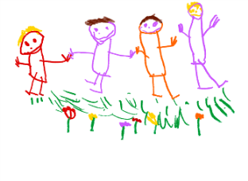

**NEWTOWN NURSERY SCHOOL**

**Equality Policy Statement**

*The Governing Body and Staff of Newtown Nursery School demonstrate their commitment to the Equalities Policy through the following statement they have prepared:*

*We aim to be as informed and knowledgeable as possible about Protected Characteristics and language, cultures, religions and beliefs to seek to promote and celebrate difference and diversity and understand issues and difficulties.*

*We want to be accepting, tolerant and celebratory and of difference bringing into our consciousness our own experiences, cultural, moral, spiritual and religious beliefs and how these may shape us and our thoughts and actions.*

*We want to ensure our resources represent and demonstrate all people and modern society but are meaningful to our community and our children’s lived experiences. We take notice and aim to celebrate all variety and individuality in our School community whilst considering individual needs and wishes. We want to offer an inclusive curriculum and an environment which meets the expectations and aspirations of all children and their families*

Our school aims to meet its obligations under the public sector equality duty by having due regard to the need to:

* Eliminate discrimination and other conduct that is prohibited by the Equality Act 2010
* Advance equality of opportunity between people who share a protected characteristic and people who do not share it
* Foster good relations across all characteristics – between people who share a protected characteristic and people who do not share it

Newtown Nursery School has due regard for advancing equality which involves:

* Removing or minimising disadvantages suffered by people due to their protected characteristics.
* Taking steps to meet the needs of people from protected groups where these are different from the needs of other people.
* Encouraging people from protected groups to participate in public life or in other activities where their participation is disproportionately low.

Our inclusive ethos and community strengths are highlighted in comments from parents and visitors and in our Ofsted Reports; ‘Newtown Nursery School is a happy and harmonious place for children to learn and play… highly ambitious of **all** children… provides the very best for **all** children… leaders expect **all** children to do well… **all** children are prepared well for their next steps in education.’

‘Newtown Nursery School ensures that all children are welcome, irrespective of their race, gender or culture…children are helped to appreciate they live in a very diverse society and develop an awareness of others’