14th January 2025

Dear Applicant

Thank you for taking an interest in the Welfare Assistant post in our school.

Kirkham St. Michael’s Church of England Primary School is firmly based in the Christian ethos of care and the importance and value of each individual member of the school family. The active links we have with the Church and the local community are an important aspect of the life of the school.

This post involves ensuring the safety, welfare and conduct of children during the lunch-time break. We welcome applications from dedicated and enthusiastic Welfare Assistants who are committed to being devoted to our children and who are supportive of our Christian ethos.

Please forward a completed application electronically to [bursar@st-michaels.lancs.sch.uk](mailto:bursar@st-michaels.lancs.sch.uk) or by hand to the School Office. Closing date for applications is noon on Monday 3rd February 2025, with interview date to be confirmed.

On behalf of the Governors, I thank you for your application.

Yours sincerely,

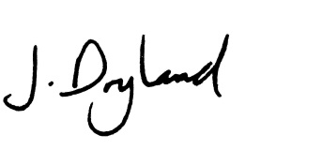

J Dryland

Headteacher