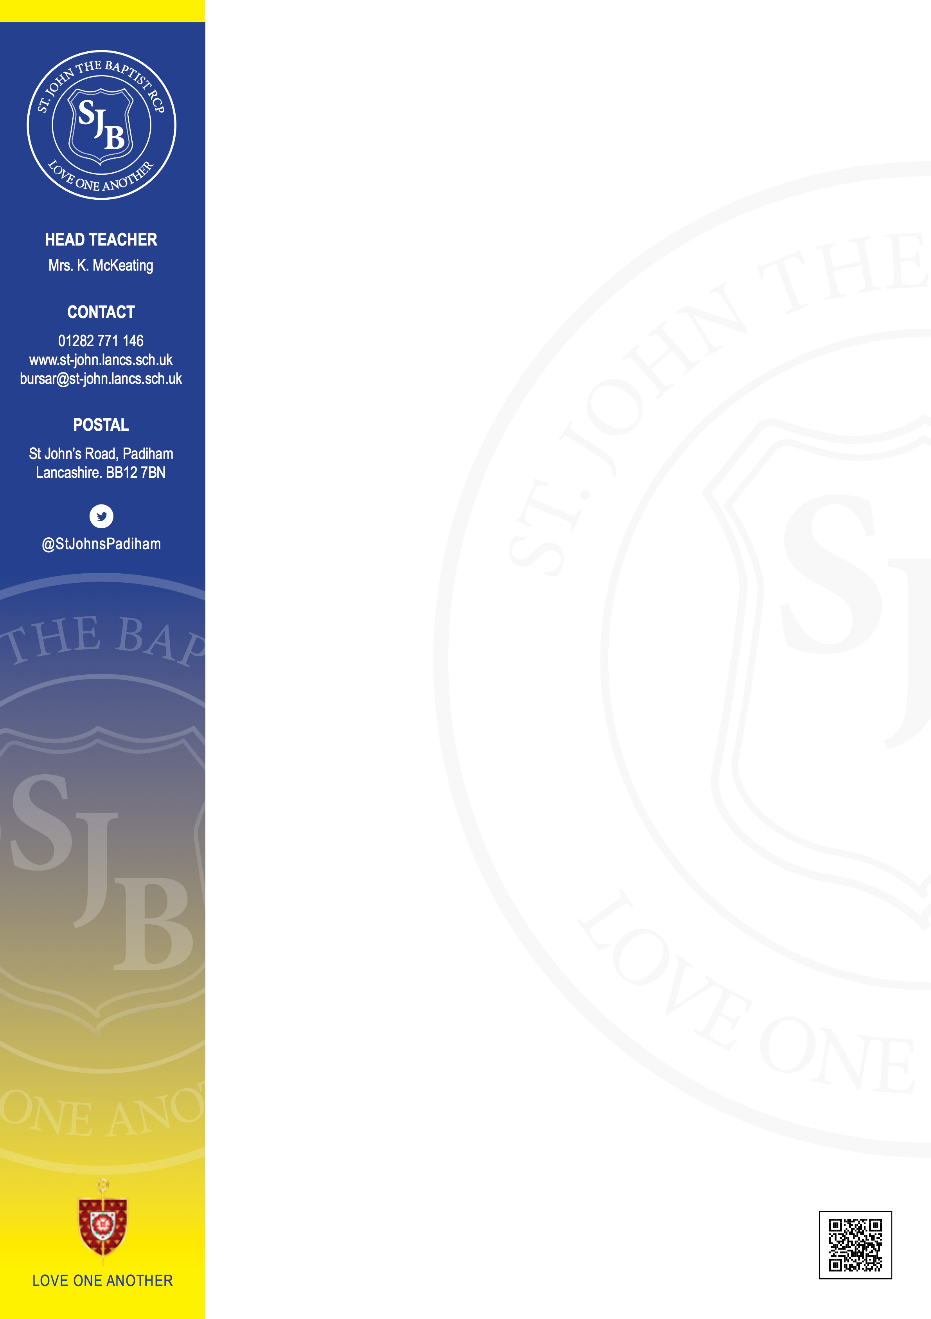
St John the Baptist Roman Catholic Primary School, Padiham -
Position: School Business Manager
Salary: £34,223 to £36, 357 (SCP25-30)
Details: 37 hours per week, Term time + 5 INSET days
NOR: 242 (including Nursery)
Closing Date: 12pm Friday 5th September 2025
Duration: Permanent
Interviews: Wednesday 10th September 2025
The interview process will include an In-Tray task and a formal interview.
Full person specification and job description are available to download website, visits to the school are welcome prior to the interview.
The Governing Board at St John the Baptist RC Primary School wish to appoint a highly motivated School Business Manager who:

- Will demonstrate the ability to manage the school’s financial resources effectively, ensuring compliance and transparency
- Can provide strategic, organisational, leadership and financial skills
- Is committed to continual improvement at a strategic level
- Is highly efficient with a fine attention to detail
- Has first class communication skills, both orally and in writing to a range of audiences
- Can provide a welcoming, professional and efficient ‘public face’ for the school
- Has the ability to prioritise and lead
- Has a problem solving and can-do attitude.
- Will develop excellent relationships with all stakeholders
- Can provide support to the Headteacher, Senior Leadership Team & Governors
- Will fully support the Catholic ethos of the school and the school’s mission statement.
For further information please ring Mrs Kathleen McKeating - 01282-771146
Please see LCC Vacancies page for further details.
More Information: http://Lancashire County Council Vacancies Page - Non Teaching Vacancies

