

EQUAL OPPORTUNITIES AT WORK
An Equal Opportunities Employer welcoming applications from all sections of the community

Why do we need the Policy?

- Lancashire County Council is striving to be an Equal Opportunities Employer.
- The Council also recognises that in the past certain groups of people have been disadvantaged in gaining employment and is tacking action to overcome such disadvantage.
- We are committed to ensuring all employees have equal treatment in the workplace and to ending any under-representation of groups in our workforce.

In seeking to implement this Policy the County Council:

- Distributes information widely on its job vacancies and encourages job applications from under-represented groups.
- Has a complaints Procedure which can be used by any employee or job applicant who feels he/she has been treated unfairly.
- Provides a variety of training courses for its staff on equal opportunity issues including recruitment and selection.
- Monitors and reviews its policy.
- Has implemented a package of flexible working arrangements.

Equal Opportunity employment Arrangements for women and men from all communities.

- Provision of job/career opportunities.
- Flexible working (Flexitime) in many locations.
- Voluntary Reduced Hours, Job Share and Career Break Schemes.
- Maternity/Maternity Support and Adoption Leave Schemes.
- Childcare Provision/Information.
- Compassionate/Special Leave arrangements.
- A recognition of religious and cultural needs in the workplace.
- A policy to deal with sexual or racial harassment and bullying issues.

Positive action for people with disabilities

- We interview all disabled job applicants who meet the essential requirements advertised for a vacancy.
- We have allocated a special budget to improve access to County Council workbases.
- We seek to retain employees and make any reasonable adjustments if they become disabled.
- We seek to assist applicants obtain employment including any necessary adjustments to the selection process.



For further details of these Policy arrangements telephone (01772) 533490

Punjabi
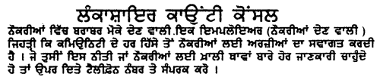

Urdu
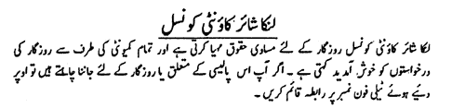

Gujarati
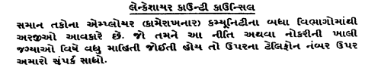

Bengali
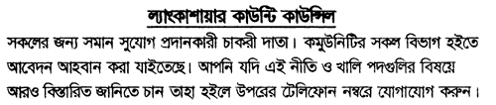

Vacancies are also advertised in the local press, Job Centres, Libraries, Information Centres and Careers Offices.

