Aldwych Drive, Ashton,
Preston PR2 1SL

Tel: 01772 513002

Web: www.ashtoncsc.lancs.sch.uk
E-mail: enquiries@ashtoncsc.com

October 2025

Thank you for your interest in the position of Headteacher at Ashton Community Science College.
After leading the school with a steady hand and unending enthusiasm for many years, the Headteacher has decided to move on to her next challenge, retirement. Her commitment to the school and determination that every student who comes to us has access to the best opportunities for their education and future life means we have a strong school culture for the next stage of the school’s life.
Ashton Community Science College (or ACSC as we refer it as) was rated 'Good’ in our most recent Ofsted report in 2024 and we have every confidence that they will continue to be impressed with our school. We have high expectations for all our students and an excellent team who nurture and support students through every part of their school life. We pride ourselves in our inclusive environment and we strive live up to our motto “a school to be PROUD of”.
Our school also offers a wide range of extra-curricular activities including musical tuition, sporting activities and school trips, as well as many opportunities to showcase skills such as school concerts and involvement in competitive and league sporting fixtures. We have invested in our facilities, the most recent refurbishments being to our changing rooms, our music rooms and our library.
Within our mainstream provision, we have 2 specialist facilities: a 20 place unit for deaf students and a 16 place unit for students with speech, language and communication needs. Places in these two facilities are by Local Authority commission only, but students in these two facilities are as much a part of our school family as those in mainstream classes.
The Governors are seeking to appoint a Headteacher with the vision and ability to keep moving the school forward, promoting greater achievements for its students, not just academically, but also providing them with the skills and mindset to take the next step in their lives. Our goal is for all our students to feel proud of what they have achieved, grateful for the opportunities they have at Ashton Community Science College and care about members of our school family. The Governing Body is committed to supporting the leadership team in providing a truly comprehensive education to the community we serve. Our new Headteacher will be someone who shares this commitment and will instil the highest standards and expectations to drive our school forward. They will also need a sound understanding of SEND principles. They must be an excellent communicator, capable of working collaboratively with staff, students, parents and the wider community.
The Governing Body comprises many experienced governors who have a wide range of complementary skills to support, encourage and challenge where appropriate. The Governors take an active role in termly meetings with middle leaders and senior leaders and recognise that the school is privileged to have such a skilled, dedicated and hardworking staff in both teaching and support roles. Ashton Community Science College is on a steady trajectory of improvement, and we were delighted with our recent year 11 attainment. Whilst there is no published progress data available for the next 2 years, we are confident that our attainment continues in the same upward trajectory and is sustainable.
Staff and students have demonstrated resilience and compassion throughout the challenges of the past few years, and whilst we are in a stable, secure position now, we know we face significant challenges in the education sector, particularly with the changes to SEND and a revised Ofsted inspection framework. While the school is financially very well managed, with consistently well-balanced budgets and excellent facilities, the financial climate remains a challenge. Ashton Community Science College must continue to work hard to ensure it remains a popular school in Preston and continues to be an asset to the community it serves.
To take the school forward, Governors are looking for a leader with a proven track record, who offers vision for our future and is supportive of students, staff, families and our wider community. This leader will ensure that the Governing Body and our staff and students can continue to be proud to be part of Ashton Community Science College and be proud of all the school achieves.
Should you decide to apply, your application letter should address how you would achieve this giving clear evidence of success in your leadership of change, its impact and how you will further raise student progress. We would appreciate an acronym-free application with a minimum of size 10 font, and a maximum of 3 sides of A4.

Yours sincerely
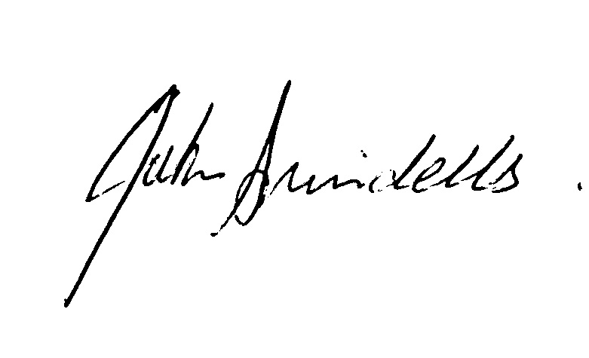
John Swindells
Chair of Governors

