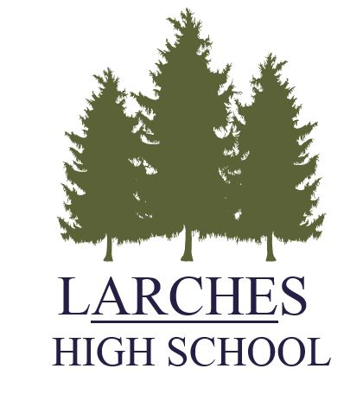
Person Specification: Hair and Beauty Instructor

FACTOR | ESSENTIAL | DESIRABLE | MEANS OF ASSESSMENT
1 SKILLS, KNOWLEDGE  AND APTITUDES | - Up to date knowledge of the hairdressing and beauty sector and current legislation relating to it.  - Excellent classroom practitioner.  - Good knowledge of assessment requirements  - Ability to engage children’s interest.  - Ability to communicate well with children.  - Good behaviour management | - Ability to use ICT effectively in teaching and learning, | Interview  Task  Application form  References
2 QUALIFICATIONS AND  TRAINING | - Level 3 in Hair and Beauty  - Level 2 English and Maths | - Assessors Award  - Industry relevant qualifications | Application form  Interview
3 EXPERIENCE | - Experience of working with young people at different levels of ability  - Experience od delivering relevant qualifications - BTech | .  - Experience of instructing  - Experience of working with challenging pupils | Application form  Interview  References
4 PERSONAL QUALITIES | - Well motivated and enthusiastic  - Commitment to success in education  - Willingness to accept responsibility and take initiative  - Good organisational skills  - Ability to motivate pupils  - Good teamwork and interpersonal skills  - Willingness to be innovative and ability to be creative  - Ability to form and maintain appropriate relationships and personal boundaries with pupils |  | Application form  Interview  References  Tasks
5. SPECIAL REQUIREMENTS | - Enhanced clearance with Disclosure and Barring Service

