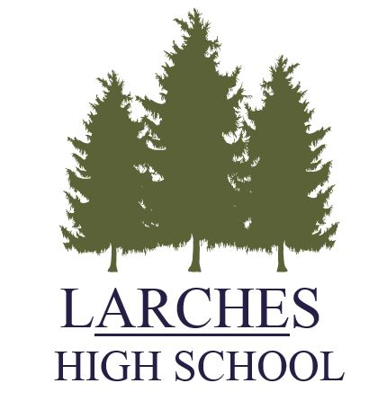
Job description for the post of:

Hair and Beauty Instructor

Responsible to: Headteacher

The purpose of this job is:
- To deliver the BTEC Hair and Beauty qualification
- To promote the educational opportunities and achievements of all students through the development of effective teaching and learning.
- To work as an effective member of the whole school team.
The particular responsibilities attached to the post are as follows:

- To teach, according to their educational needs, pupils assigned to the allocated classes, including the setting and marking of work.
- Assess, record and report on the progress, development and attainment of pupils and to keep such records as are required.
- Undertake a designated programme of teaching.
- To maintain the care of the salon, ensuring that it is compliant with health and safety regulations and the department risk assessments.

The school will be subject to continuous review, therefore, further responsibilities outlined may change after consultation but initially will be as follows:

- To set a good example to the pupils, through presentation and personal and professional conduct.
- To contribute to the school’s management of overall organisational development through staff meetings, Key Stage meetings and working groups both within the school and with other maintained Alternative Provison schools.
- To take an active part in appropriate professional development activities, including staff induction, whole school in-service training and performance management.
- To contribute to activities which will provide opportunities for pupils’ social and cultural development.
- To establish a partnership with parents/carers to involve them in their child’s learning of subjects, as well as providing information about the curriculum, attainment, progress and targets.
- To establish clear expectations and constructive working relationships with support staff involved with subject teaching, including team working and mutual support; developing responsibilities and delegating tasks as appropriate and evaluating practice.
- To maintain good order and discipline among the pupils and safeguard their health and safety both when they are authorised to be on school premises and when they are engaged in authorised school activities elsewhere.
- To sustain their own motivation and, where possible, that of other staff involved in working with our pupils.
- To assist in the preparation, monitoring and revision of School Support Plans.
- To undertake any other duties and responsibilities which are consistent with the grade and expertise required of the postholder as may be required from time to time.
- To ensure the development and progression of equality within the sphere of responsibility of this job description and the fair and equal treatment of all pupils, parents/carers, staff, other personnel in the school or working with the school.

Equal opportunities
We are committed to achieving equal opportunities in the way we deliver services to the community and in our employment arrangements. We expect all employees to understand and promote this policy in their work.

Health and safety
All employees have a responsibility for their own health and safety and that of others when carrying out their duties and must help us to apply our general statement of health and safety policy.

Safeguarding Commitment
We are committed to protecting and promoting the welfare of children, young people and vulnerable adults.

Customer Focus
We put our customers' needs and expectations at the heart of all that we do. We expect our employees to have a full understanding of those needs and expectations so that we can provide high quality, appropriate services at all times.

