September 2025
Dear Candidate,

Thank you for your interest in the role of Deputy Headteacher at Little Hoole Primary School, starting January 2026. We are delighted you are considering joining our community.

Our motto “Enabling all to Believe, Grow and Achieve” guides everything we do. We are proud to be a caring, inclusive, and ambitious school where children flourish. Our staff work closely together to provide an excellent education, nurturing both achievement and personal growth. The children are enthusiastic, curious, and proud of their school, and our families are supportive partners in their learning.

Our pupils are especially excited about welcoming a new Deputy Headteacher and have created a word cloud to share the qualities they most want to see.
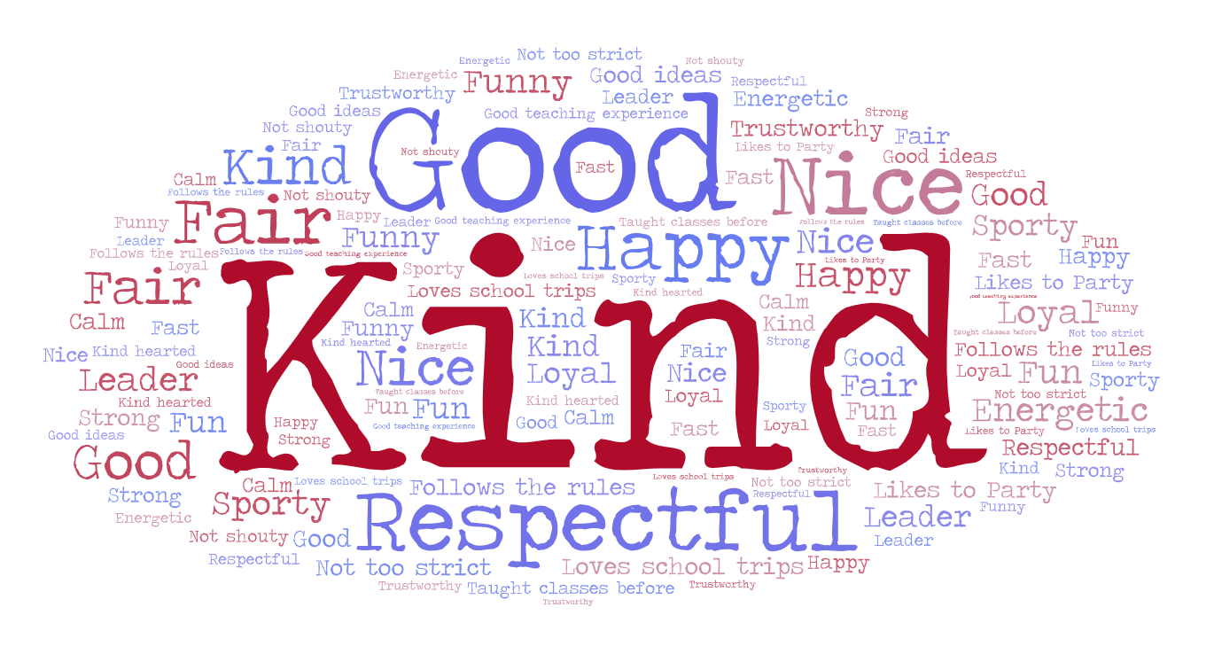
Within your pack you will find:
- Job Description
- Person Specification
- Governor Letter (shared with parents & carers before the end of the last school year)

We encourage you to explore our website www.littlehoole.lancs.sch.uk and to arrange a visit to meet our children and staff, so that you get a sense of the belonging and aspiration that defines Little Hoole.

We look forward to receiving your application and learning how your skills, experience, and aspirations could enrich our school community.

Best wishes,
Mr. Stammers
Headteacher

