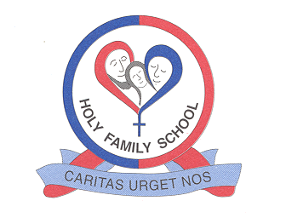
Holy Family
Catholic Primary School

59 Whitby Avenue, Ingol, Preston, Lancashire PR2 3YP
Telephone: (01772) 727471 Fax: (01772) 725122 Email: head@holy-family.lancs.sch.uk
Website: www.holy-family.lancs.sch.uk
Headteacher: Mrs L Morrison

Dear Candidate,

On behalf of the Governors of Holy Family Catholic Primary School, I would like to thank you for your interest in the position of Teacher. I am delighted that you are considering applying to join our school family.
Holy Family is a happy and welcoming Catholic school where we love, serve and strive to do our best. We are a one form entry primary school with an admission number of 25 pupils each year. We are keen to appoint a person who is passionate about providing our children with the care and education they deserve.
We are looking for an excellent teacher to join our team of skilled and dedicated staff.
We are on an exciting journey as we look forward to becoming part of the Mater Ecclesiae Catholic Multi Academy Trust and would like to appoint someone who:
- Is a driven, self-motivated team player
- Is an excellent and inspiring teacher and role model to children and staff.
- Is fully supportive of and committed to our strong Catholic ethos.
- Is a hard working, loyal member of our team who will contribute to making our school even better and is willing to participate in the wider life of the school

If you are interested in applying we encourage visits to school, please contact us to make arrangements. We look forward to hearing from you.

Yours sincerely

Mrs Lindsey Morrison

Headteacher

