

Head Teacher: Mrs J Henderson
01524 832747
Langridge Way
Westgate
Morecambe
LA4 4XF

8th May 2025
Teacher Vacancy
Dear Candidate,

Thank you for taking an interest in our current vacancy for a teaching post at Westgate Primary School. We are potentially looking for 1 full time teacher, temporary for 12 months in the first instance beginning 1st September 2025.

We are seeking applications from qualified teachers within the Main Pay Scale range (M1-M6). The teaching position is likely to be in a Key Stage Two class.

Westgate is very large mainstream primary school with just under 550 pupils, serving the community in Morecambe. The pupils are at the centre of everything we do with a committed, experienced and hard-working staff base meeting the needs of the children we are responsible for.

The ideal candidate will be someone who is child-centred, compassionate and resilient. We are looking for individuals who can truly support children and be part of a team that make a positive and life-long difference.

We have an excellent record in terms of supporting the development of teachers and we hold our staff in very high regard, they are our most valuable resource and so we take time to nurture and value them. Staff enjoy coming to work and give 100% to both children and colleagues. We all work hard here and our efforts are rewarded with the satisfaction gained from seeing youngsters move on with their learning.

The school population comes from a range of backgrounds, free meals entitlement is 40.5% and many have difficulties outside school. We have a strong inclusion team to support our work with these particular children.

We are looking for someone who:

- is a high-quality teacher practised in Quality-First Teaching and whose references reflect this
- Cares passionately for all our children, no matter what their barriers are or challenges they bring into school.
- has the ability and skills to teach throughout the whole primary age range
- can deliver inspiring and creative lessons in a meaningful and coherent cross-curricular way
- understands the importance of building up subject-specific skills before applying them in context
- has a thorough knowledge of the National Curriculum, in particular the current expectations across the year groups so that all pupils achieve well
- embraces change and is passionate about planning and delivering an inspiring curriculum
- can work effectively within a well-established team, jointly planning and working collaboratively
- can, or has the potential to, lead a subject confidently, thoroughly understanding the progression of skills, subject content and attainment at all levels through school whilst actively promoting their subject area and supporting colleagues
- applies consistent behaviour management strategies that promote the school’s policy
- sets very high standards for themselves and holds themselves to account for their performance
- has a sense of humour

In return, we can offer:

- an experienced and welcoming staff who are passionate about helping children to achieve their very best
- enthusiastic children who are rightly very proud of their school
- a challenging, context-based curriculum that promotes the acquisition of life skills and an enquiry-based approach to developing children’s subject-specific skills
- the opportunity to further develop your own career path in a supportive and forward-thinking environment, surrounded by like-minded staff
- a positive, supportive and happy place to work, where children are at the centre of everything we do and that everyone has a ‘can do’ attitude

This school is committed to safeguarding and promoting the welfare of children and young people and expects all staff and volunteers to share this commitment. We have a designated senior member of the leadership team who is responsible for referring and monitoring any suspected case of abuse. All members of staff will receive training in line with our child protection policy. All shortlisted candidates will be subject to a rigorous safeguarding check.

As we are expecting a large number of applications for these posts we will not be able to respond to each applicant personally. The closing date is Tuesday 3rd June, so if you have not heard from us by Friday 6th, please assume your application has not been carried forward to the next stage. If this is the case please accept our thanks for your application and our best wishes for any further applications you might be making.

We would like to invite prospective candidates to visit the school. If you are interested in the post, please come and meet us and get a feel for our school and our children. Tours will take place on the following dates;

- Tuesday 19th May at 4pm
- Thursday 22nd May at 4pm

Booking is essential please call us on 01524 832747 to book your place.

If you like a challenge, don’t mind hard work and want to make a difference, please fill in your application and return it to us by 3pm on Tuesday 3rd June. Please email applications to e.nutt@westgatesch.com.

Yours sincerely,
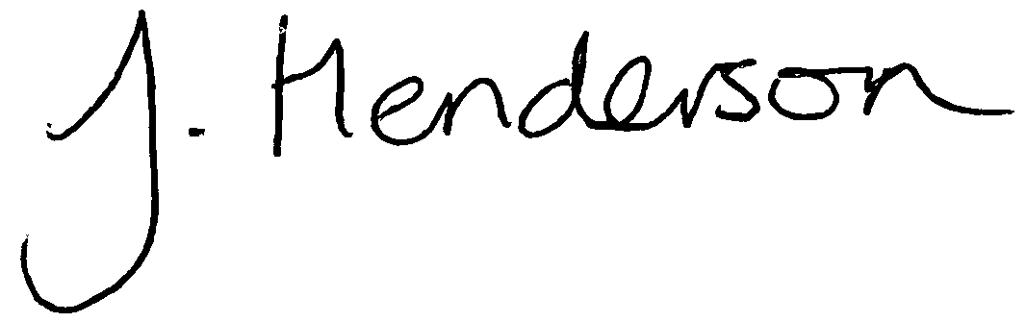

Jane Henderson
Head Teacher
Westgate Primary School

