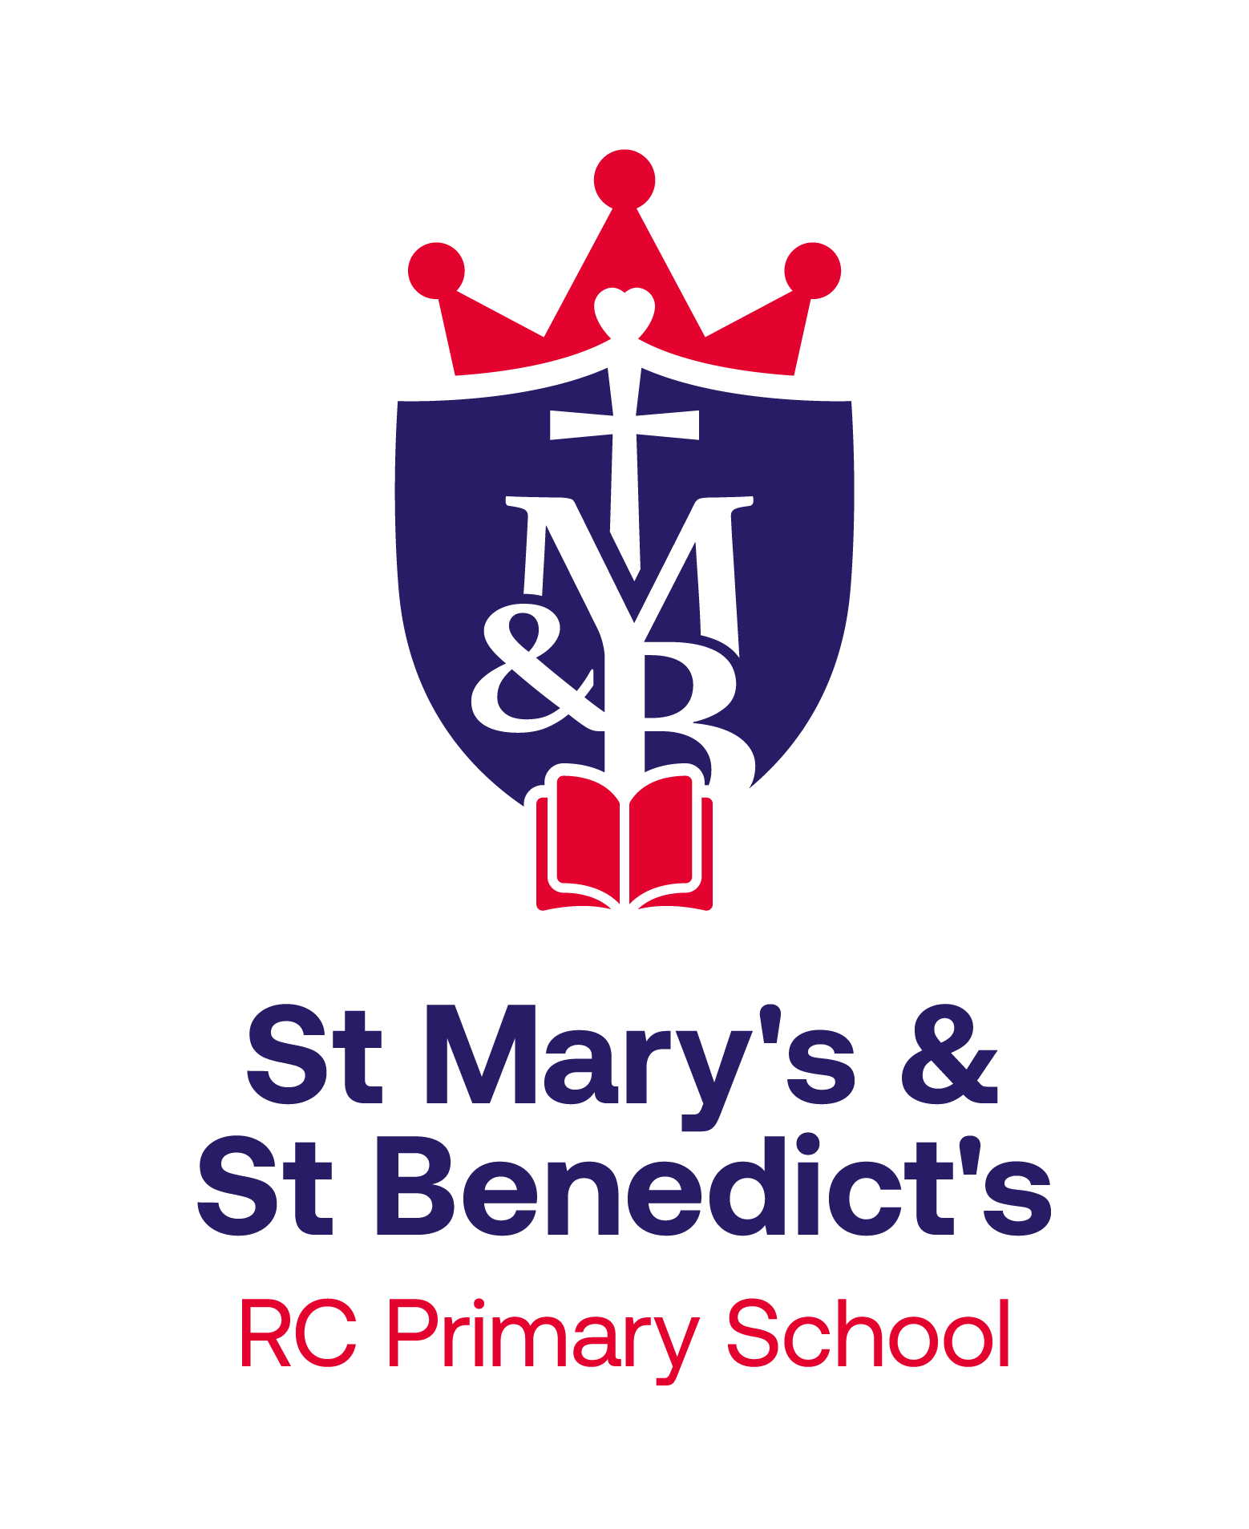
St Mary’s & St Benedict’s Catholic Primary School
Brownedge Lane, Bamber Bridge, Preston PR5 6TA
Phone: 01772 336650
Email: office@smsb.lancs.sch.uk
www.smsb.lancs.sch.uk
Headteacher: Mr Daniel Ballard
Thursday, 1st May 2025
The governors of St Mary’s & St Benedict’s are seeking to appoint an inspirational, enthusiastic and dedicated individual to join the teaching team. Like with all teaching positions for the year 2025-26, this is a full time position. We are looking for a talented member of staff to share our vision in continuing to build upon the achievements of this dynamic Catholic School.
We are seeking teachers who:
- put children at the heart of everything they do;
- have a clear understanding of Catholic education and the vision and ability to lead and develop the Catholic Life of the school;
- understand the importance of physical and mental health wellbeing for everyone in our community;
- will follow the lead of the Headteacher and Senior Leadership Team in managing the school;
- are hardworking team players who show excellent communication, interpersonal and organisational skills to draw together staff, governors and parents;
- can work as part of the team to help us becoming a consistently ‘Good’ school;
- can build on the existing strengths of the school and help to develop our talented team of staff;
- have the resilience to ensure the continued success of the school;
- have a track record of highly impactful contribution in their class/es;
- are skilled at building up positive relationships with children, colleagues and parents;
- have an understanding of all 3 phases of the primary school;
- are strong classroom practitioners.

Number on roll: 264

Salary: Main Pay Spine

To start: 1st September 2025

Closing Date: Monday, 19th May at 12 noon

Shortlisting: Tuesday, 20th May, 2025

Observations: Thursday, 22nd May or Friday 23rd May

Interview: Thursday, 22nd May or Friday 23rd May

Documentation: Person Specification, Job Description and application forms are all available from Mrs Jayne Coulton – upon request.

On behalf of the Governing Body of St Mary’s & St Benedict’s RC Primary, I wish you the best of luck.
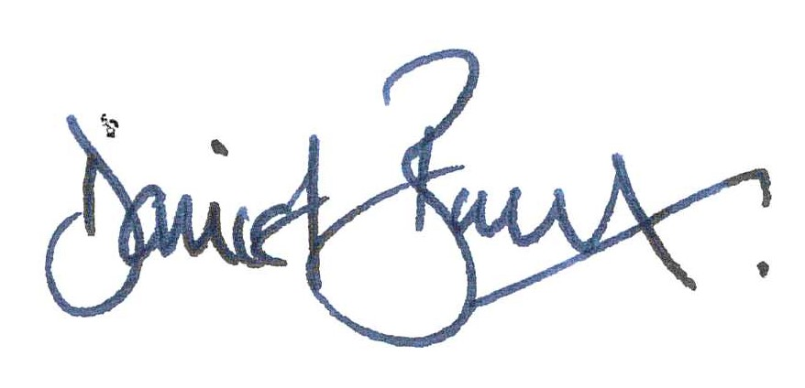

Mr Daniel Ballard
Headteacher

