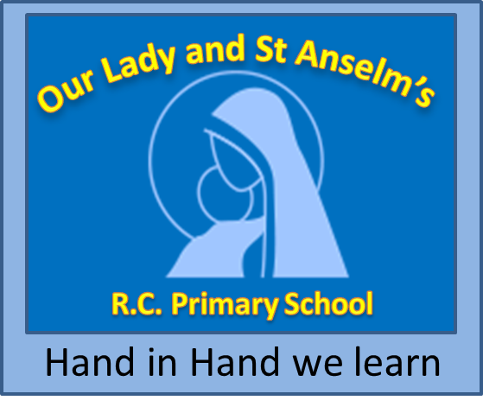
Our Lady and St Anselm’s R.C. Primary School
John Street, Whitworth, Rochdale, Lancashire. OL12 8DB.
Telephone/Fax: 01706 853545
Headteacher: Mrs J Rainey, BA (Hons) with QTS

e-mail: head@olsa.lancs.sch.uk
web site: www.olsa.lancs.sch.uk

CLASS TEACHER (MPS)
Full Time, Permanent Contract
(Required September 2025)

The Governors are seeking to appoint an outstanding teacher to join our fantastic school which is driven by a simple, yet ambitious vision ‘to inspire excellence’. Our Lady & St. Anselm’s has a strong Catholic ethos with a clear sense of purpose.

Applications are invited from recently qualified teachers and experienced teachers who are passionate about education and have the drive to inspire our wonderful children.

Ideal candidates will:
- Be a practising Catholic/Christian with a commitment to supporting the Catholic ethos of our school.
- Be an outstanding teacher with very high expectations of what can be achieved.
- Have a clear understanding of what excellence in education looks like.
- Have the drive to develop practice with the whole primary phase.
- Be an enthusiastic, inspirational and caring teacher.
- Be committed to promoting high standards of attainment
- Be vibrant, dynamic and fun!

In this role, you will:
- Have the opportunity to work with eager, well behaved children with a thirst for learning.
- Be part of a school with its mission at its heart reflecting a rich faith dimension.
- Be part of a committed staff team, focused on continuing to raise standards within teaching and learning.
- Be supported and offered excellent provision for career development and CPD.
- You will be offered the opportunity to complete qualifications through the Catholic Training Programmes i.e. CCRS.
- Be given opportunities to be innovative.
- Have the support of stakeholders within a growing community.

“Our Lady and St Anselm’s is an outstanding Catholic Primary School. Upon entry to the school one is struck by the wonderfully warm and friendly welcome given to all.” Salford Diocesan Religious Inspection (April 2017.)

Our Lady & St. Anselm’s R.C. Primary is committed to safeguarding and promoting the welfare of the children and young people and expects all staff and volunteers to share this commitment. The post is subject to an enhanced CRB and medical clearance and satisfactory references.

Visit to school: Friday, 2nd May May 2025
The closing date for applications is: Tuesday, 6th May 2025 (Noon)
Short-listing: Tuesday, 6th May 2025
Lesson Observations: Monday, 19th May 2025
Interviews for Successful Applicants: Monday, 19th May 2025

