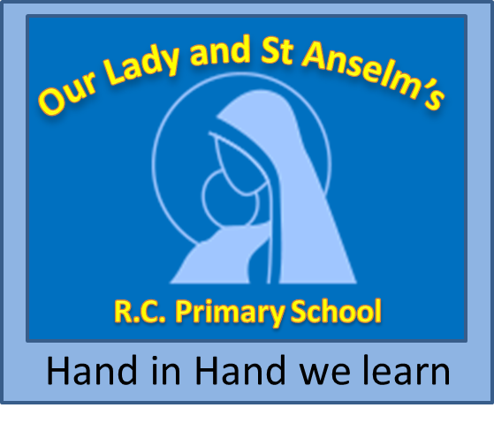
Our Lady and Saint Anselm’s R.C. Primary School
Personnel Specification

Permanent Class Teacher

CANDIDATES MUST BE ABLE TO PERFORM ALL DUTIES AND TASKS WITH REASONABLE ADJUSTMENT, WHERE APPROPRIATE, IN ACCORDANCE WITH THE PROVISIONS OF THE DISABILITY DISCRIMINATION ACT 1995

ATTRIBUTES | REQUIREMENT  ESSENTIAL | REQUIREMENT  DESIRABLE
Qualifications | Qualified teacher status  Degree | Any other qualifications relevant to primary teaching  Recent participation in in-service training.
Written Application | A well-constructed and professionally written application, showing clear thinking about primary education and ideas to meet the requirements of the post.  Enhanced DBS Disclosure  Supportive references
Personal Faith | Be committed to uphold the Catholic ethos of the school | A practising Catholic
Experience and Skills | Success in teaching children, with a clear understanding of the teaching provision required within the new curriculum.  Ambition to be a highly successful teacher.  Good knowledge of the National Curriculum, assessment and tracking  Knowledge of the mastery curriculum  Good understanding of and commitment to inclusion.  An understanding of the needs to differentiate learning activities for the children of different needs / abilities.  A good understanding of Child protection and safeguarding within a school.  A willingness to take on a subject lead and to be an effective ambassador for their subject. | Success in teaching experience across Stage 1 and Key Stage 2.  Application of ICT to teaching and learning.  Experience of working with other colleagues to plan a skill based learning programme.  Successful experience of working with children with special needs.  An ability and willingness to extend the extra-curricular provision for children.

ATTRIBUTES | REQUIREMENT  ESSENTIAL | REQUIREMENT  DESIRABLE
School Ethos | A belief in pupil centred active learning with an ability to stimulate and challenge.  Ability and willingness to work collaboratively within the school team, making a contribution to planning and curriculum development.
Relationships | An ability to provide a caring, co-operative atmosphere for children and to create a challenging, disciplined and effective learning environment.  Excellent class management and control.  An ability and willingness to relate to individuals and groups and form excellent relationships with children, parents, and all adults connected with the school  and / or other agencies as necessary.  Ability to work as part of a team, directing and supporting teaching assistants where appropriate. | An understanding of the support children need to achieve self-discipline.
Attitude and Temperament | Positive attitude to teaching role. A willingness to develop personal, professional skills.  Ability to be self-critical and accept advice.  A willingness to take on appropriate delegated tasks.  Tidy and organised.  Ability to prioritise time effectively
Appearance and Health | Smart appearance.

