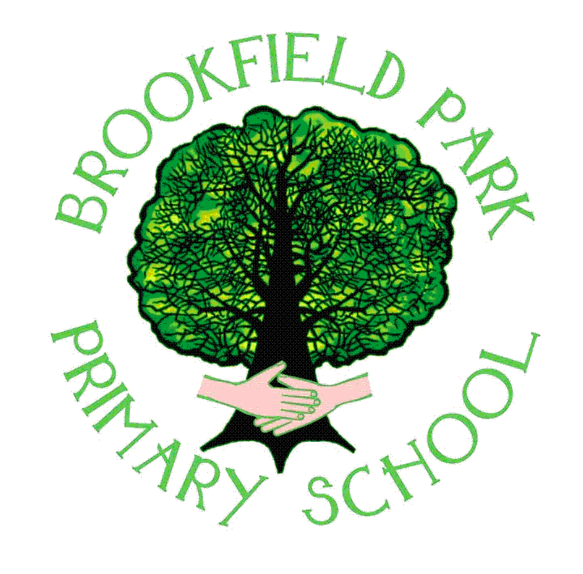

School Lane Campus School Lane, Skelmersdale, Lancashire, WN8 8EH
tel: 01695 724042 fax: (01695) 550738
office email: bursar@brookfieldpark.lancs.sch.uk

Head teacher: Sarah-Jane Whiteside

Dear Applicant,

I am delighted that you have taken an interest in our temporary class teacher post. Please be aware that the post is offered as temporary but may be made permanent subject to the school budget and performance of the successful candidate.

We are a school that is firmly rooted in our community, as such we feel that we know our families and children so well that the education we provide them is very much tailored to suit their needs and allow them to flourish. The children are at the heart of everything we do, and we are dedicated to providing the best education that we can, along with developing the whole child through a wealth of experiences and wide-ranging opportunities.

Located in Skelmersdale, we are a one form entry school with 165 pupils currently on roll. We are very proud of our thriving nursery provision, which is situated in our purpose built EYFS unit. A key aspect of our school, and one that sets us apart from the rest, is our co-location with Kingsbury Special School. We run as two separate schools but with a shared commitment to providing all of the children on the campus with the best facilities and educational opportunities possible.

We are looking to appoint an enthusiastic, creative and experienced class teacher who is strongly committed to becoming part of our successful team. Particularly important to us is someone who can demonstrate a positive attitude to change and fully engages with the school vision:

When looking to the future, our vision is to ensure that Brookfield Park is increasingly regarded as:

- being the number one provider of nurture and wellbeing in our community
- being the school built on good behaviour, empathy and consideration for others
- being one of the best schools in our community for both academic achievement and life skills development
- being a school with a rich and broad curriculum tailored to meet the needs of every child
- being the school of choice and the thriving hub of the community

Our school promise summarises what we expect from our pupils every single day in every part of their lives:

At Brookfield park Primary school:
We are always kind
We are always resilient
We always take ownership

Along with the role of class teacher there is an expectation that you will lead at least two subjects. As we are currently looking to restructure some of the staffing and subject responsibilities we would love to hear about any knowledge, experience and passion/desire you may have in a particular subject area.

We can offer you:

- A fantastic, hard working and experienced staff team who are always welcoming towards new colleagues
- A supportive and approachable SLT who are focussed on driving the school towards continued excellence
- Wonderful, enthusiastic, warm and happy children who enjoy coming to school
- An enthusiastic and dedicated governing board, who are keen to work with staff and parents to continue to make our school the best it can be
- Well-resourced and generously spaced learning environments which make our children proud to attend Brookfield Park Primary School

If you want to find out more about our school please visit our website:
https://www.brookfieldparkprimary.co.uk/

We very much look forward to receiving your application.

Yours Faithfully,
Sarah-Jane Whiteside
(Headteacher)

