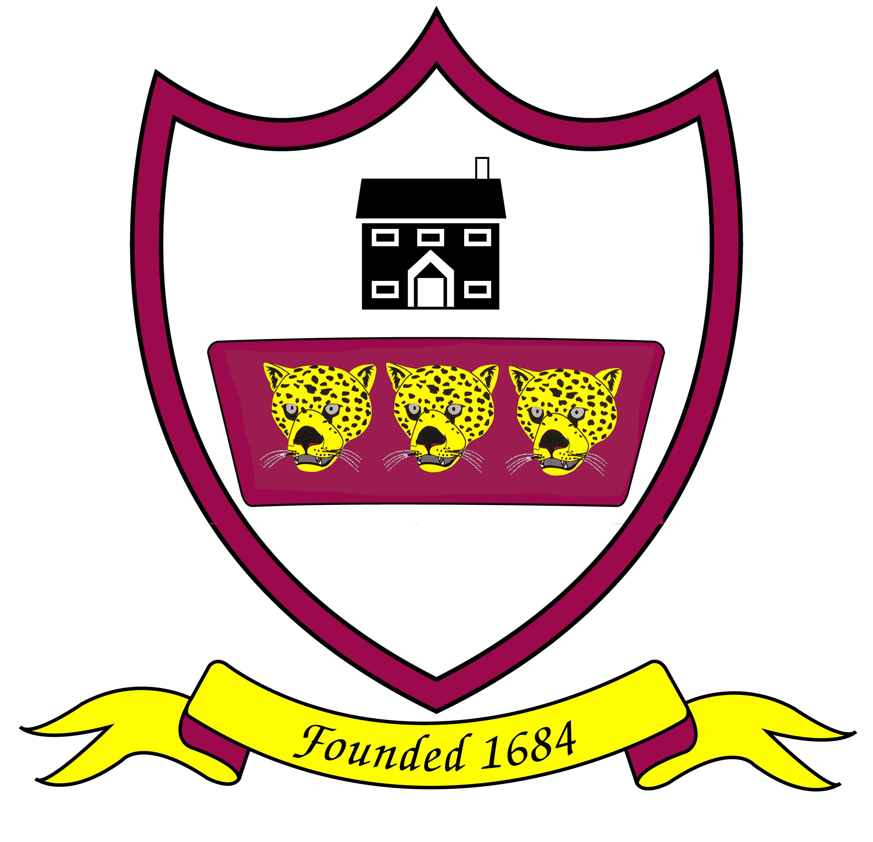

Brabin’s Endowed School
Longridge Road
Chipping, Preston
Lancashire
PR3 2QD
Tel:01995 61596
Fax: 01995 61828 Headteacher: Mrs RA Wallace BA Hons NPQH
Email: head@brabins.lancs.sch.uk

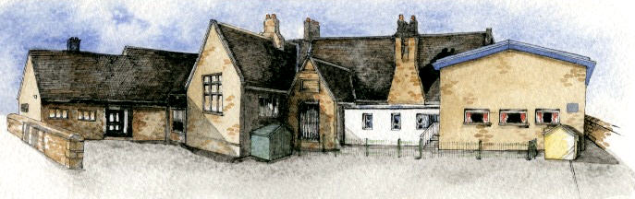

Serving its Community
For over 320 years

___________________________________________________________________________________

Dear Candidate,
Thank you for showing an interest in the permanent Y3/4 Class teacher vacancy at Brabin’s Endowed Primary School. Our school is based in the rural village of Chipping and has a strong Christian ethos with close links to St Bartholomew’s Church.
Brabin’s School works tirelessly in its drive for excellence and this was reflected in our ‘Outstanding’ Ofsted Inspection, June 2024. We are committed to ensuring that we continue to go from strength to strength, in providing the highest quality of education for our children, through a broad and balanced curriculum. Our curriculum is enhanced by a high quality extra-curricular programme, aiming to foster a love of learning, where all children can access a wide range of quality experiences and enrichment opportunities.
The school also places a high emphasis on well-being and we encourage every child to develop as an individual within a nurturing environment. Our biggest asset is the Brabin’s community as we have a strong dedicated team with happy, confident children. I recommend that you come and visit the school to see for yourself.
We are looking for an excellent classroom practitioner who is ambitious and highly-motivated. The successful candidate must be committed to forming excellent relationships with the children and the school community in its entirety. In return, we can offer a caring environment in which we are fully committed to supporting staff development.
Once again, thank you for expressing an interest in this vacancy. Please email head@brabins.lancs.sch.uk to arrange a visit to the school and to discuss the role in more detail.
Yours sincerely

Mrs Rachel Wallace
Headteacher

