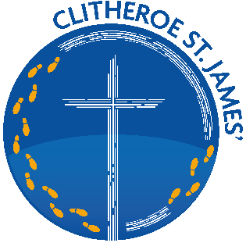
CLITHEROE ST JAMES’ C.E. PRIMARY SCHOOL

Headteacher: Mr J Leeming

Tel: 01200 423599 Email: head@st-james.lancs.sch.uk

School website: www.stjames-clitheroe.co.uk

Greenacre Street, Clitheroe, Lancashire, BB7 1ED

11th March 2025

Dear applicant,

Thank you for your interest in working at our wonderful school. You will be able to download the following from the advert:

- Application form
- Job Description
- Person Specification Form

We look forward to receiving your completed application form along with a “letter of application” by 12 noon on Tuesday 22nd April.

Please check our website where you can find more information about the school. You are encouraged to visit the school to ensure that we are the right school for you. If you would like to book an appointment, please contact the school office.

Yours sincerely,

Mr Leeming

Headteacher

