Burscough Bridge Methodist Primary School
Orrell Lane,
Burscough,
Ormskirk,
L40 0SG
Tel 01704 892307
www.burscoughbridgemethodistschool.co.uk
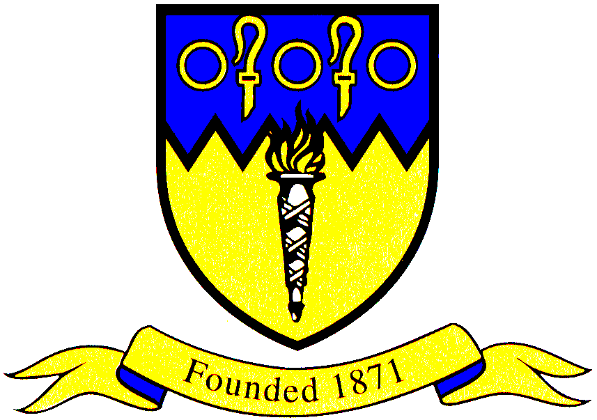

10th February 2025

Dear Candidate

Thank you for your interest in the position of Part Time Class Teacher at Burscough Bridge Methodist School.

We are a small family orientated school situated in the heart of Burscough. Our values of Love, Respect, Hope, Forgiveness, Trust and Perseverance underpin our whole approach to teaching and learning. Our aim is to offer a nurturing environment to ensure the best possible education and opportunities for all of our pupils.

The governors, staff, and children are keen to appoint an outstanding classroom teacher who has high expectations in all areas of school life and a passion for ensuring the very best outcomes for all our children. We are looking for a teacher who is a team member who will make a positive contribution to school life, the wider community and to our extra-curricular provision. The successful candidate will have the opportunity to take on leadership of a curriculum area.

Our school website https://burscoughbridgemethodistschool.co.uk has more information and really shows the flavour of our school, our children and our community. We warmly invite you to visit our school and meet members of our team. Visits are being held on Thursday 25th March at 1.30pm or after school can be arranged. To book a visit please contact Mrs Forshaw in the school office by telephone or email bursar@burscoughbridge.lancs.sch.uk.

We look forward to receiving your application

Kindest regards

Mrs L Tyrer

Headteacher

The closing date for applications is Friday 3rd March 2025, 12 noon.
Observations/interviews will take place Week beginning Monday 7th March 2025.

Let your Light Shine | 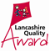

,

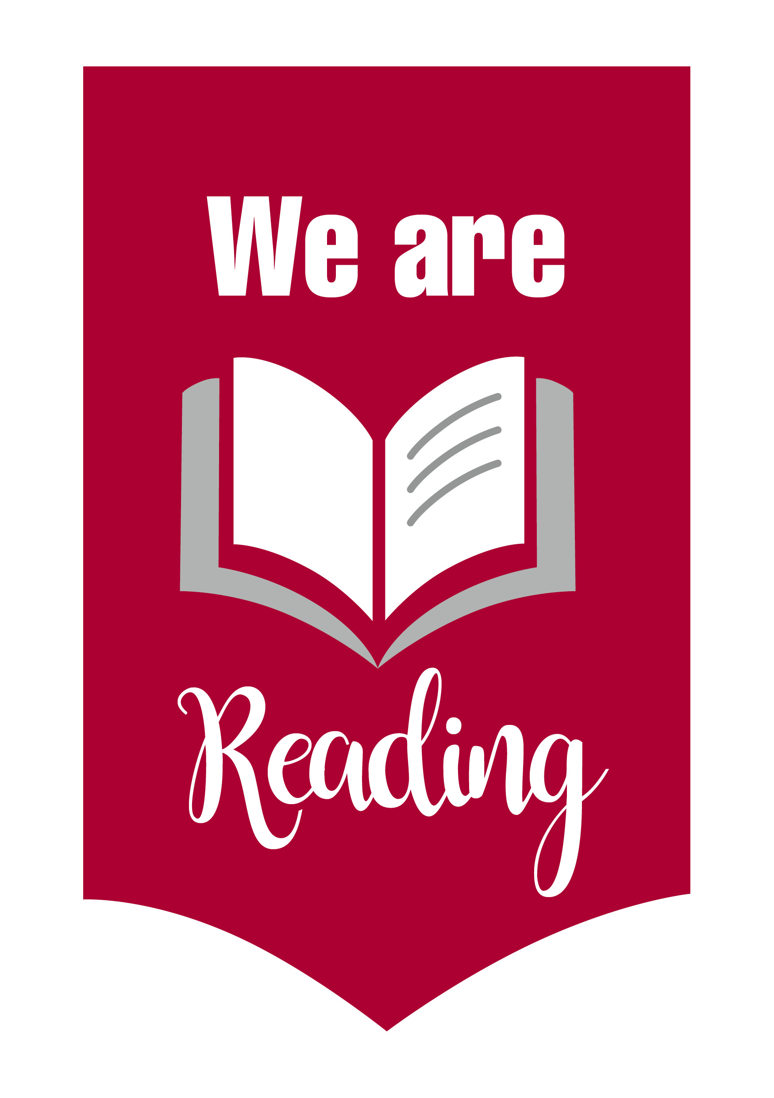

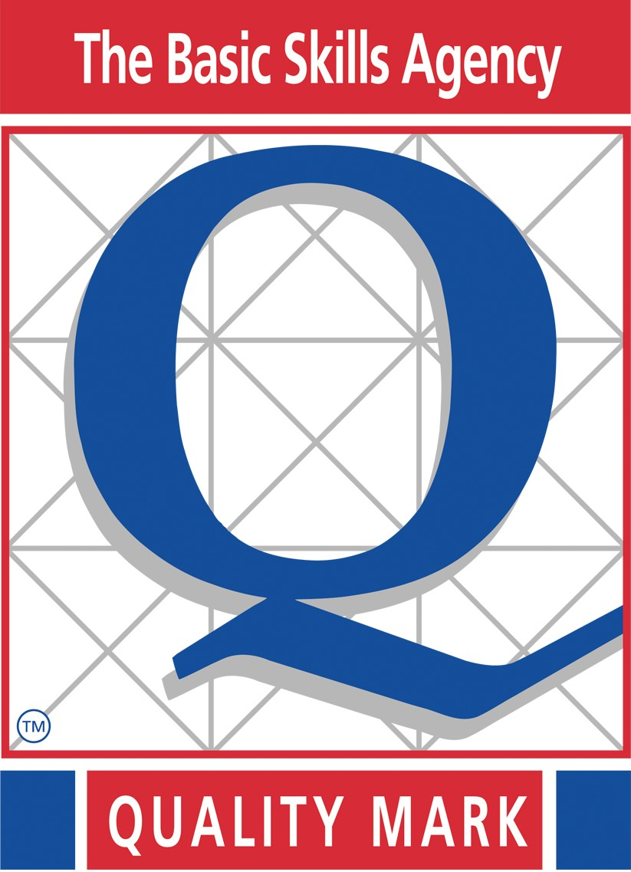

Mission Statement
‘Let Your Light shine to all’ (John Wesley)
Through exciting opportunities in lessons and the wider curriculum our children become well rounded, caring changemakers in our world. Each child is at the heart of all we do, to ensure they become the best they can be and are meant to be.

