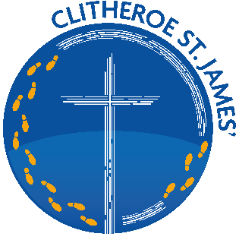
CLITHEROE ST JAMES’ C.E. PRIMARY SCHOOL

Headteacher: Mr J Leeming

Tel: 01200 423599 Email: head@st-james.lancs.sch.uk

School website: www.stjames-clitheroe.co.uk

Greenacre Street, Clitheroe, Lancashire, BB7 1ED

February 2025

Dear Candidate,

Thank you for your interest in the post of deputy headteacher at Clitheroe St. James’ CE Primary School.

The school is situated in beautiful and spacious grounds in the centre of Clitheroe. It is easily accessible by road and rail. We are currently in phase two of an exciting building programme and are hoping that a new bespoke modular KS1 / EYFS building will be in place later this year. The final phase will see a refurbishment of the original splendid Victorian building.

We serve a diverse community and visitors frequently comment about the good behaviour of our pupils and how keen they are to learn. We have ten classes with an admission number is 45 (one and a half form entry). Bowland Pre-School, accommodated on our site, offers places to children aged 2-4 who generally enrol to our school.

Governors are passionate about the holistic development and well-being of every pupil. We are proud of our “BOLD” vision for the school where children are taught to Believe (in themselves), be Open, Love (learning and others) and be Determined. Every child is valued as part of our ‘school family’. The successful candidate will be an inspirational leader who will contribute fully to maintaining and developing this vision.

We are blessed with extensive and engaging school grounds, including an Eco Zone, which is at the forefront of our Forest School provision. The large grounds lead onto a recently developed community nature reserve; this offers a pleasant route to school for our families, as well as opportunities for the children to explore the environment during school hours.

We are very supportive Governing Body who are excited by the prospect of working alongside our new deputy headteacher to help take our school onto the next stage of its journey.

The closing date for applications is Friday 7th March at 12 noon with shortlisting on Tuesday 11th February. Interviews will take place on Friday 28th March with pre-interview sessions on Thursday 27th March. We strongly recommend visiting the school prior to making an application. Please contact the school office and the headteacher, Jonathan Leeming, will be pleased to welcome you.

When completing your application form please follow these guidelines:
- Complete your application online, submitting the Blackburn Diocese Application Form.
- Ensure that your supporting letter is concise. Please do not submit a CV instead of an application form.
- Refer to the diocesan guidance on faith references included in the application pack.

Many thanks for showing an interest in our amazing school and we look forward to receiving your application.

Yours sincerely

Mark Clayton

Chair of Governors

