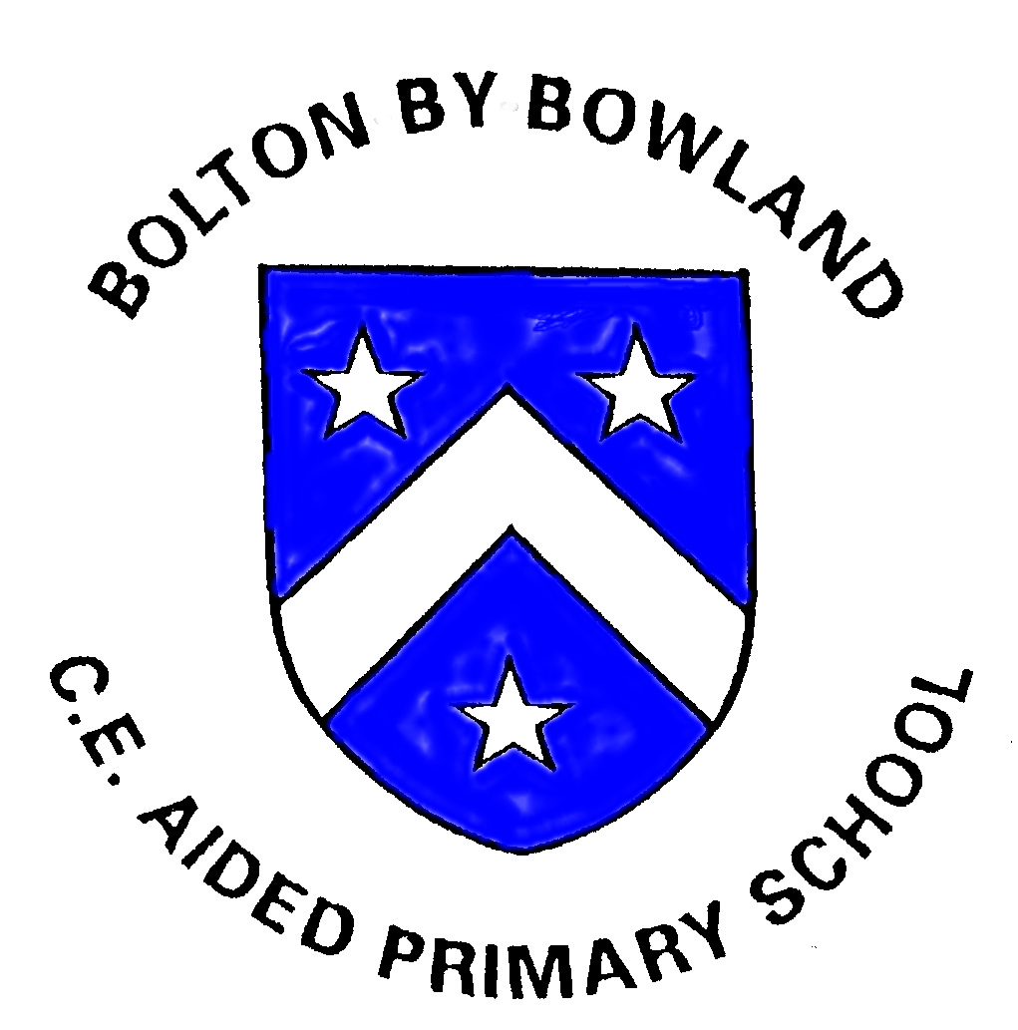
Bolton-by-Bowland CE Primary School
Gisburn Road, Bolton by Bowland Nr Clitheroe Lancs. BB7 4NP
Tel: 01200 447632
Email: head@bolton-by-bowland.lancs.sch.uk
Website www.bolton-by-bowland.lancs.sch.uk
Class Teacher Vacancy

Dear prospective applicant,

Thank you for your interest in the post of Class Teacher at Bolton-by-Bowland Church of England Primary School.

We are a small, rural school located in in the picturesque Forest of Bowland, Lancashire, where we strive to give our children the very best opportunities in the most idyllic village setting.

We are a small, friendly, Christian school with excellent relationships with our children, their families, church, our local high schools and the wider community.

Our skilled and dedicated staff work together as a fantastic team with the focus on continual improvement and a core purpose of doing what is in the best interest of the children we serve.

We are a school on an exciting journey of improvement and feel this is a wonderful opportunity for a dedicated and enthusiastic teacher with experience of working in a mixed-aged class to join our hardworking team. If you have read the job description, looked at our website and think you could enhance our team, we look forward to receiving your application.

The position is permanent.

Please contact Mrs Awre on 01200 447632 if you would like to visit our friendly and vibrant school.

Closing Date: Thursday 13th February 2025
Interview Date: Tuesday 25th February 2025

I look forward to receiving your application.

Yours sincerely
J Abram
Executive Headteacher

