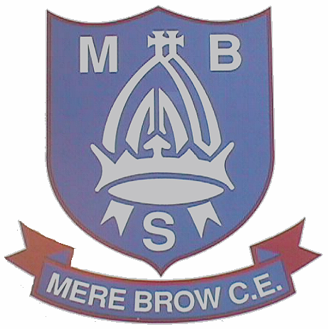
TARLETON MERE BROW CHURCH OF ENGLAND
PRIMARY SCHOOL

The Gravel, Mere Brow, Preston, Lancashire.PR46JX

Telephone: (01772)812689
E mail head@merebrow.lancs.sch.uk
Web site : www.merebrow.lancs.sch.uk

Year 6 SHINE Ethos Group
15/1/25

Dear Applicant,

We would like our new Head teacher to be funny and comedic but still responsible. The new Head teacher needs to carry on with all the good things we do but could also think about a Y6 buddy program and let the Y6 run some clubs.

The new Head teacher needs to be someone who is kind, helpful and listens to you when you feel down. They need to get to know us all well, including if we have any disabilities.

The new Head teacher needs to be up to date, financially responsible and good with technology. They need to advertise our School so that we can grow and be encouraging to everyone.

We look forward to meeting you on 14th March for Worship and a chat.

Yours sincerely,

The Shine Ethos Group and Head pupils, Y6.
JP, Daniel, Erin, James, Seb and Willow.



