JOB ADVERT
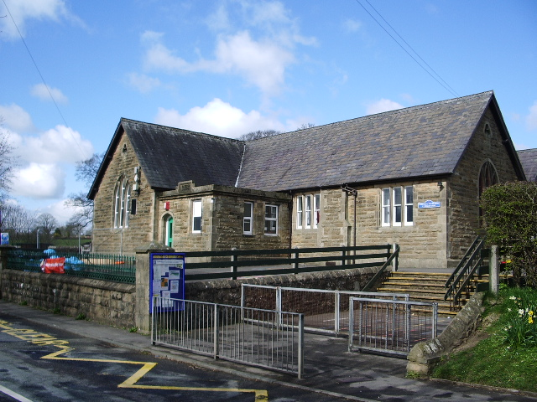
Waddington and West Bradford CE Primary School
West Bradford Road, Waddington, Clitheroe, BB7 3JE
Number on roll 191

Required from January 2024 or as soon after that as possible
KS2 teacher (Year 3)
Salary: Main Point Scale

The Headteacher and Governors are seeking to appoint a highly motivated, inspiring and creative teacher to teach in KS2 – Year 3.

Waddington and West Bradford CE Primary School is a highly successful and effective village school; a place where children, staff, parents and Governors are happy and actively involved in all aspects of the children’s education. We strive to be the best we can be and pride ourselves on delivering an inspiring and creative curriculum where every child is valued. We are looking for an exceptional teacher who is excited at the prospect of becoming part of our hardworking, dedicated and enthusiastic team.

We can offer:

- A positive, caring and inclusive ethos.
- Happy children with a thirst for knowledge.
- A dedicated, determined and dynamic staff team.
- A bright and stimulating working environment.
- Attractive outdoor learning environment.
- A supportive and effective Governing Body.
- Opportunities for continued professional development.
- A Senior Leadership Team who support staff and prioritise staff wellbeing

We require someone with:

- A proven record of effective classroom practice in KS2.
- A commitment to our Christian Ethos and a drive to enable every child to shine
- A commitment to our positive, inclusive and creative ethos.
- A solid understanding of the principles of effective teaching and learning in KS2.
- The ability to inspire and motivate all pupils.
- Extremely high standards, of themselves and their pupils.
- Determination, energy and ambition.
- The skills to develop and sustain a purposeful learning environment, inside and outside
- The ability to work closely with our families
- Creativity

Please note that in line with Keeping Children Safe in Education 2024, an online search will be carried out as part of our due diligence on shortlisted candidates

Please speak to Mrs Sarah White (Headteacher) to discuss this and ask any questions about the role.

Advertised from: 8th November 2024
Closing Date: Monday 25th November 2024
Shortlisting: 26th November 2024
Interviews: TBC

