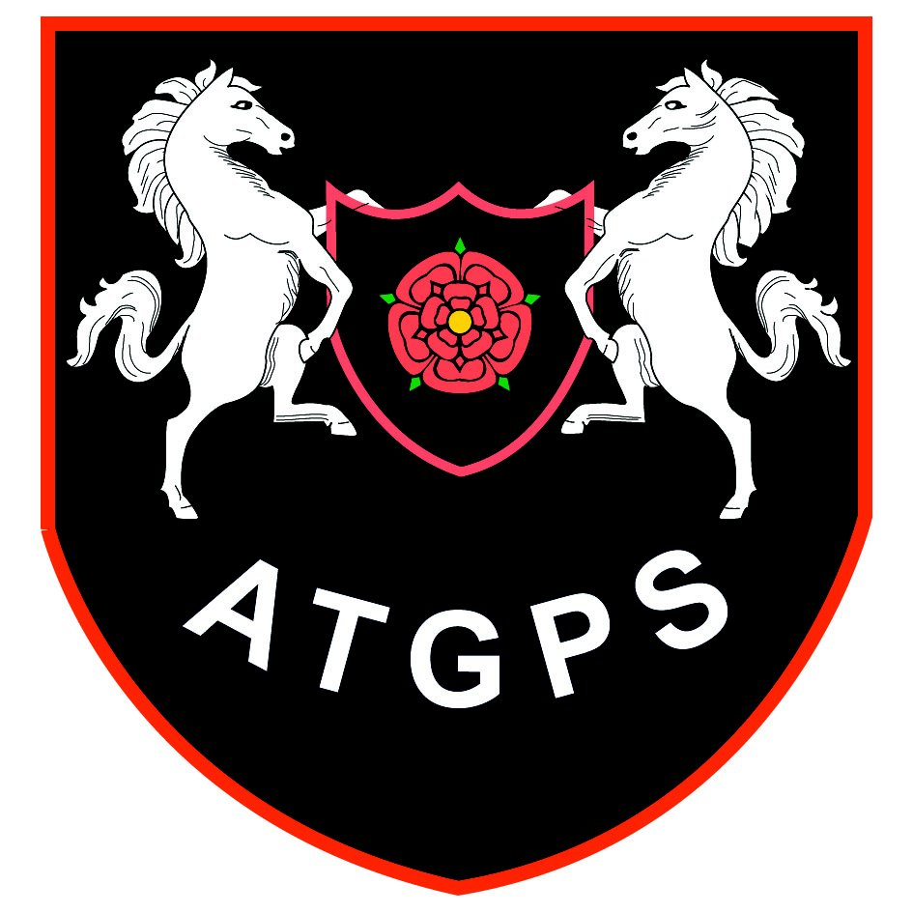Aughton Town Green Primary School

JOB DESCRIPTION

Job description for the post of: Main Scale Teacher
Directorate: Children and Young People |  |  |  |  |  | Location: |  | Education
Establishment or team: |  |  | Aughton Town Green Primary |  |  |  |  |  |  | Post number:
Grade: | MPS |  |  | Line manager: | Headteacher |  |  |  |  | Car user:
Staff  Responsibility : |  |  | Number of staff  directly supervised: TA in class |  |  |  | Name.
Key Tasks
Class Teacher: Responsible for the effective teaching and organisation of a class of children

- Plan, prepare and evaluate programmes of work to meet the educational needs of the children
- Organise resources for effective teaching; enable all children to benefit from the activities provided
- Ensure a safe, well organised and stimulating classroom including displays of recent work
- Develop caring and trusting relationships with children
- Maintain the highest possible standards for children’s work
- Maintain the highest standards of discipline and respect, inside and outside the classroom
- Assess, record and evaluate pupil progress
- Report to parents on pupil progress; promote parental involvement

Professional Development
- To follow the Professional Standards for Teachers.
- Review teaching methods; participate in further training courses and activities
- Participate and contribute to organisational, curriculum and administrative meetings
- Participate and cooperate in the performance management procedures as appropriate
- Undertake and conduct all duties in line with the requirements of the School Teachers’ Pay and Conditions document

Assist in School Organisation
- Work cooperatively with other staff and governors to achieve the aims and objectives of the school
- Assist and cooperate with colleagues and ancillary staff
- Assist in the organisation of school events; support school activities organised by others
- Report to governors if required
- Undertake other duties as required by the Headteacher to ensure the smooth and efficient running of the school and the education of the children

General
- To promote the general progress and well-being of individual pupils and of any class or group of pupils assigned.
- To provide guidance and advice to pupils on educational and social matters.
- To make records of and report on the personal and social needs of pupils.
- To communicate and consult with the parents of pupils.
- To communicate and cooperate with persons or bodies outside the school.
- To participate in meetings arranged for any purposes described above.
- To organise and develop the skills of pupils through extra-curricular clubs.

Prepared by: |  | N Huxley |  |  |  |  |  |  | Date: |  | September 2024

Equal opportunities
We are committed to achieving equal opportunities in the way we deliver services to the community and in our employment arrangements. We expect all employees to understand and promote this policy in their work.

Health and safety
All employees have a responsibility for their own health and safety and that of others when carrying out their duties and must help us to apply our general statement of health and safety policy.

Safeguarding Commitment
This school is committed to safeguarding and protecting the welfare of children and young people and expects all staff and volunteers to share this commitment.

