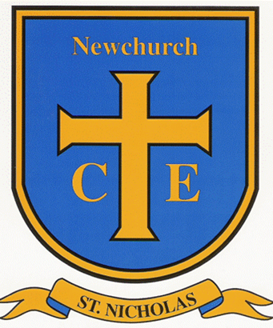
Newchurch St. Nicholas Church of England Primary School
Dark Lane, Newchurch, Rossendale, Lancashire BB4 7UA
Telephone 01706 229478 Fax 01706 260570
Headteacher G. Callaghan

How we live out our vision – Newchurch St Nicholas is a school which supports all its community to thrive and flourish now and in the future. Everyone in the community is empowered to hold a strong sense of personal identity, an unshakable notion of self-worth, recognise their God-given potential and the impact of God’s love on them.

Start children off on the way they should go and when they are old they will not turn from it. Proverbs 22:6

We are seeking to appoint a highly motivated and talented Deputy Headteacher to work alongside our hardworking, dedicated team and support our new headteacher leading the school in the next exciting chapter of its story. They will work alongside the Headteacher to lead and inspire us in our drive to build on our current good practice and to continue to raise pupil achievement.

The Governors are looking for a highly motivated, enthusiastic and nurturing leader with a clear educational philosophy and vision to join our happy church school. The successful candidate will be flexible, creative, ambitious and eager to make a difference in our children’s lives, they will have excellent interpersonal and communication skills with the ability to work as part of and to lead an effective, dedicated team.
As a Church of England Primary School, it is important that our new Deputy Headteacher can create, inspire and embody our Christian ethos and culture of this Church school, securing its mission statement with all members of the school community and ensuring an environment for teaching and learning that empowers both staff and students to achieve their highest potential.

This is a great opportunity for a strong, confident, and effective leader to have a significant impact on a school whose staff are committed to providing a safe and nurturing environment, where every child is able to become the best version of themselves.

We are looking for a class-based deputy headteacher, who:

- Has the skills and knowledge to monitor, evaluate and influence whole school improvement.
- Has excellent organisational skills.
- Demonstrates drive, experience and creativity to build on our current high standards of teaching through continuous school improvement.
- Is committed to safeguarding the welfare and wellbeing of children, staff and visitors.
- Has excellent interpersonal skills and the ability to establish and develop strong professional relationships with colleagues, governors, parents, children and the wider community.
- Is a flexible team player with a cheerful disposition.
- Will strive to make a positive difference to the lives of all of our pupils.
- Has a good understanding of all three key stages in the primary phase.
We can offer:

- A happy welcoming school where everyone is valued
- A caring and Christian ethos
- Well behaved and happy children who are proud of our school
- A committed and supportive governing body
- Good opportunities for continuing professional development
- Strong partnerships with parents, other schools and the local community
- Beautiful grounds and views from school
- A strong supportive Governing Body with a clear vision for the future of the school

Prospective candidates are encouraged to visit the school prior to application. Please contact the school office to arrange a visit.

Shortlisting Date: 2nd October
Interview Date: 16th October

