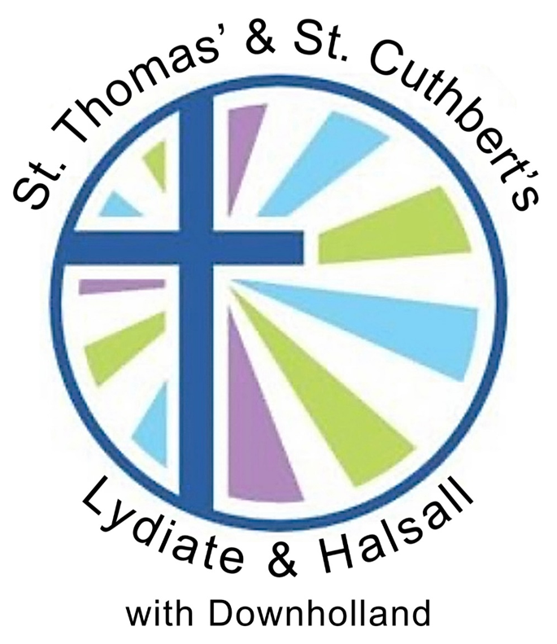

Rev’d Dr Susan Salt
Rector St Cuthbert’s Halsall and St Thomas’s Lydiate and Downholland

The Vicarage, Church Lane, Lydiate, Liverpool, L31 4HL

Tel. 07730 197656; E-mail: rectorhalsallandlydiate@gmail.com

June 2024

As a church, St Thomas‘ prides itself in serving the local community including Haskayne. We strive to be an inlusive, hospitable, welcoming and generous congregation, serving God and making His love known.

We are looking forward to working alongside a headtacher who is an inspirational leader as well as an inspiring teacher, who looks to care for each child, member of staff and wider school communty holistically.

We hope you will feel able to join us in worship on occasions and work with us to insprire the next generation to be the best version of themselves in mind, body and spirit and so enable their lights to shine.

