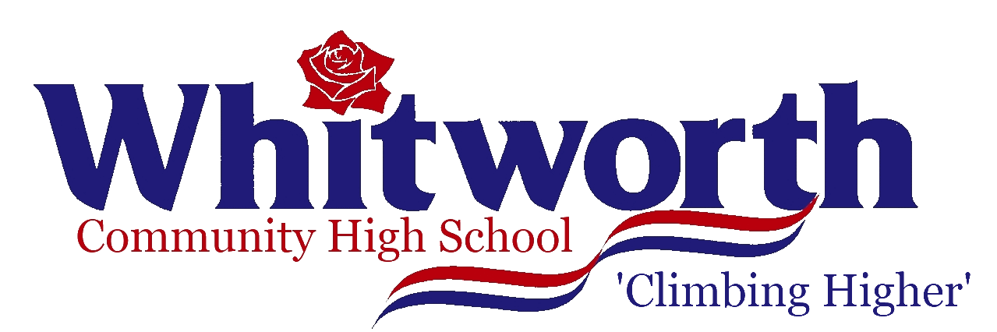 | WHITWORTH COMMUNITY HIGH SCHOOL

JOB DESCRIPTION FOR THE POST OF: Main Scale Teacher

Grade: | Main Scale |  | Responsible To: | Director of Learning  Teacher in Charge
DUTIES:

The duties outlined in this job description are in line with those covered by the latest School Teacher’s Pay and Conditions Document. It may be modified by the Headteacher, with your agreement, to reflect or anticipate changes in the job, commensurate with the salary and job title.

Main Duties:

- Professional Standards
  - Fulfil the National Teachers’ Standards
  - Support the aims and ethos of the school as defined in the staff handbook and school handbook
  - Act as an outstanding role model in terms of professional appearance, conduct, punctuality and appearance
  - Maintain a purposeful and calm atmosphere in the classroom, upholding and applying agreed policies and practice for learning, behaviour and uniform in a consistent, firm and non-confrontational manner
  - Take responsibility for professional development and progression, making full use of the opportunities and training provided by the school
  - Attend team and staff meetings as appropriate, contributing actively whenever possible

- Teaching and Learning
  - Carry out teaching duties within the school’s schemes of learning, the National Curriculum (where applicable) and public examination specifications
  - Plan and deliver lessons and other learning activities in accordance with the school’s Teaching and Learning protocol, ensuring that all students make progress towards clear learning objectives across all contextual groups
  - Liaise with other colleagues to prepare and deliver units of learning in a collaborative way ( the contribution reflecting the post holder’s level of responsibility)
  - Ensure that suitably differentiated material and learning pathways are provided to challenge all student regardless of ability
  - Set appropriately aspirational targets for students’ attainment based on prior data
  - Set work for students absent from lessons in line with school’s policies

- Assessment, Recording & Reporting
  - Maintain rigorous and accurate records, including students’ attainment & progress, attendance, home learning set and outline lesson plans
  - Assess and return student work regularly and in line with the school’s Teaching and Learning Protocol. Marking should include clear feedback for improvement and progress for each student.
  - Provide assessment reports when required within the school’s assessment cycle and any additional reports when requested.
  - Assist the Director of Learning/Teacher in Charge in carrying out suitable evaluation and analysis of examination results and performance and agreeing actions as necessary
  - Work within the code of practice relating to Disability and Special Educational Needs, liaising as necessary with SENCO.

- Form Tutor
  - Build relationships with all students and be available when needed to listen and offer support and encouragement
  - Maintain high standards within the tutor group including monitoring punctuality, uniform, home learning, attitude and behaviour
  - Ensure the accuracy of registers
  - Disseminate school information via the form powerpoint

Prepared by: |  | Headteacher |  |  |  | Date: | Autumn 2023

EQUAL OPPORTUNITIES: The School is committed to achieving equality of opportunity both in the delivery of services to the community and its employment arrangements. We expect all employees to understand and promote our policies in their work.

HEALTH AND SAFETY: All employees have a responsibility for their own Health and Safety and that of others while undertaking their duties. Employees have a general duty to assist the School in implementing its general statement on the Health and Safety policy.

Agreed By:

Employee……………………………………………………….Date……………………….

Headteacher……………………………………………………Date……………………….

