
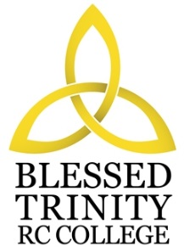
BLESSED TRINITY RC COLLEGE
JOB DESCRIPTION
Job Title Teacher of Geography
Grade Main Pay Scale – Upper Pay Scale
Responsible To Curriculum Leader
Scope You will be required to teach pupils aged between 11 and 16 in Geography.

Job Purpose The main objectives to be achieved by the post holder

- To maintain and build upon the standards and professional duties as outlined in Teachers’ Pay and Conditions.
- To manage pupil learning through effective teaching in accordance with subject scheme of work and policies, ensuring continuity and progression.
- To implement and deliver an appropriately broad, balanced, relevant and differentiated curriculum for pupils and to support a designated curriculum area as appropriate.
- To monitor and support the overall progress and development of pupils as a class teacher/form tutor.
- To facilitate and encourage a learning experience which provides pupils with the opportunity to achieve their individual potential.
- To contribute to raising standards of pupil attainment throughout the school.
- To share and support the school’s responsibility to provide and monitor opportunities for personal and academic growth.
- To work as a member of a designated team and to contribute positively to form effective working relationships within the school.

Since this is a Roman Catholic college you are expected to support the Catholic ethos of the college as stated in the Vision Statement.
Note: In addition, other duties at no higher level of responsibility may be interchanged with/added to this post as required.

