

Ashworth Road, Rossendale, BB4 9JE
Tel: 01706 214081 Email: head@st-anne-edgeside.lancs.sch.uk
Dear applicant,

Thank you for your interest in the post of year 3 class teacher at our school. St Anne’s Church of England Primary School is a happy place to learn and work. We are passionate about nurturing the whole child, and we are committed to upholding our Christian foundations and living out our core values.

We are looking for an excellent practitioner to join our team, who will inspire our children to be the best that they can be. This appointment has arisen due to teacher changing career. The successful candidate will be part of our teaching team of seven classes and a nursery.
Our school has two sites. The original building houses our Key Stage 2 classes, hall and offices. Our Early Years and Key Stage 1 departments are housed across the road from the original site with their own play areas.
As a result of a great deal of hard work, dedication and excellent team work, St Anne’s was graded as ‘good’ in our most recent Ofsted inspection in 2018. This is something our school is very proud of and we now talk of being on our journey to ‘awesome’. The schools’ motto reflects this, ‘Be awesome, shine bright!’

As you will already have seen from the job advertisement and person specification, St Anne’s Church of England Primary School is looking for a class teacher who is committed to securing the very best outcomes for all children and is prepared to think creatively and go the extra mile to achieve this. The successful candidate should share our high expectations whilst reflecting the values of our school within their day-to-day practice.

Our staff have extensive knowledge across many areas, and the successful candidate will be provided with professional development opportunities from working alongside these individuals as well as opportunities to join networks and learn from others outside of school.

We are committed to staff wellbeing and we actively have initiatives and are conscious of staff work load and making the job of a class teacher manageable and enjoyable.

Visiting our school will provide you with a deeper sense of what we are about – many people say the school has an especially warm feeling! We hope you will visit us prior to applying. Thank you for expressing an interest in joining our team.
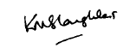
Kind regards,
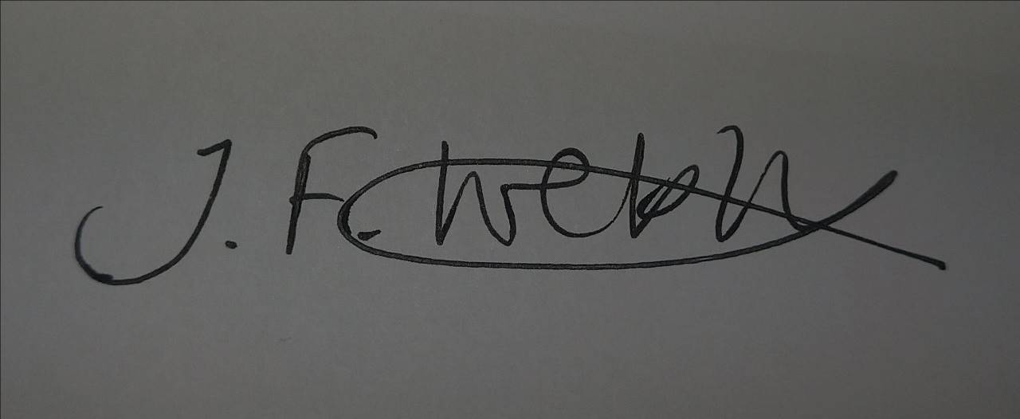
Jayne Webb Headteacher Kath Slaughter Chair of Governors

