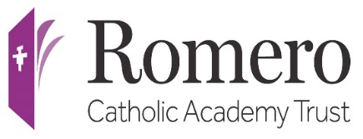
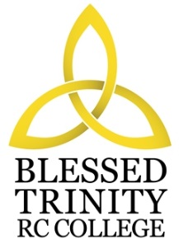

BLESSED TRINITY RC COLLEGE

PERSON SPECIFICATION

COVER TEACHER

Attributes | Essential | Desirable
Experience | Experience of teaching preferred subject throughout the Key Stage
Qualification | Teaching Qualification  Degree in a relevant subject
Special  Knowledge | Knowledge and understanding of current developments and initiatives in the delivery of the subject across the Key Stages | Conversant with the planning and delivery of courses
Practical and  Intellectual Skills | Effective organisational skills with regard to pupils and resources  Good communication skills, both oral and written  Good classroom management skills | Strong ICT skills

