
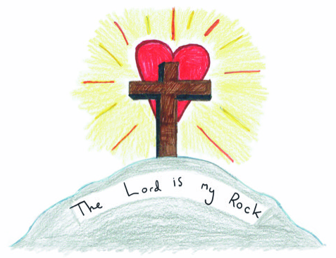
School Lane
Simonstone
Burnley
BB12 7HR

Head Teacher: Mrs. C Smith
Tel: 01282 771147
head@simonstone.lancs.sch.uk

Dear Future Teacher,
We are the pupils in year 5 at Simonstone St Peter’s C of E Primary School. We can’t wait to welcome you to our school and hope that you visit for a pupil tour.
If you are the following, you will be our perfect teacher: kind, compassionate, firm yet fair, accepting, loyal and motivating. You will invest in our vision and our Christian values of love, kindness, respect and justice. Justice is our class value!
We are looking for a teacher who will respect every child and embrace all our differences. We would like you to be organised, plan trips and visits and also to be positive, friendly and fun.
We will try our best to make you feel safe in the school environment and we will work as hard as we possibly can in every subject. We will be respectful, helpful and welcoming. You will work in a fun learning environment, with well-behaved pupils. Our parents are very supportive and we all work together to achieve our best.
We hope you have all the skills needed to provide us with a good education and help us to flourish, whilst also preparing for our futures.
We look forward to meeting you and will proudly show you our school.
Yours sincerely,
Current year 5 pupils (soon to be year 6!)

