
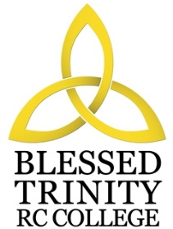

BLESSED TRINITY RC COLLEGE
JOB DESCRIPTION

Job Title Teacher of Food Technology
Grade MPS
Responsible To Curriculum Leader
Scope You will be required to teach pupils aged between 11 and 16 in Food Technology, as well as Art at Key Stage 3. You will be expected to work as part of a team assisting the Curriculum Leader of the department in organisation and administration and the extra curricular life

Job Purpose The main objectives to be achieved by the post holder:

- To maintain and build upon the standards and professional duties as outlined in Teachers’ Pay and Conditions
- To manage pupil learning through effective teaching in accordance with subject schemes of work and policies, ensuring continuity and progression
- To deliver an appropriately broad, balanced, relevant and differentiated curriculum for pupils and to support a designated curriculum area as appropriate
- To monitor and support the overall progress and development of pupils as a class teacher/form tutor
- To facilitate and encourage a learning experience which provides pupils with the opportunity to achieve their individual potential
- To contribute to raising standards of pupil attainment throughout the school
- To contribute to the extra-curricular and faith life of the school, both within the Design and Technology Department and as an active participant in the liturgical life of the school
- To share and support the school’s responsibility to provide and monitor opportunities for personal and academic growth
- To work as a member of a designated team and to contribute positively to form effective working relations within the school.

Since this is a Roman Catholic College you are expected to support and promote the Catholic ideals of the school as stated in the Vision Statement.
Note: In addition, other duties at no higher level of responsibility may be interchanged with/added to this list as required.

