
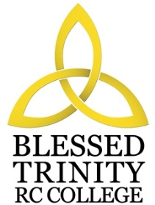

BLESSED TRINITY RC COLLEGE
PERSON SPECIFICATION

TEACHER OF SCIENCE

Attributes | Essential | Desirable
Experience | Experience of teaching preferred subject throughout the Key Stages | Some experience and knowledge of Citizenship/PHSE
Qualification | Teaching qualification  Good Science degree | Recent CPD in Curriculum; willingness to take part in CPD  Delivery and Learning
Special  Knowledge | Knowledge and understanding of current developments and initiatives in the delivery of the subject across the Key Stages | Conversant with the planning and delivery of courses
Practical and  Intellectual Skills | Effective organisational skills with regard to pupils and resources  Good communication skills, both oral and written  Good classroom management skills | Ability to contribute to whole school policies and initiatives
Physical | Good Health  Excellent record of attendance and punctuality

Blessed Trinity is committed to safeguarding and promoting the welfare of children and an enhanced DBS disclosure will be required.

