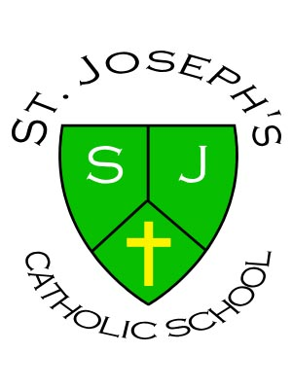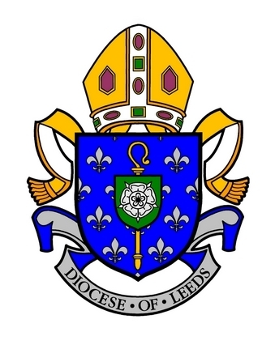
ST. JOSEPH’S CATHOLIC PRIMARY SCHOOL
West Close Road, Barnoldswick, Lancashire, BB18 5EN
Telephone: 01282 813045

“With Jesus at the centre of all we do and say”

MATERNITY COVER
Year 1/2 Class Teacher
Required for October 2022

The governors are seeking to appoint an excellent KS1 classroom teacher for a maternity cover, who wishes to develop professionally within a caring and supportive environment.
St. Joseph’s is a small mixed aged Catholic Primary School, located in Barnoldswick in Lancashire and close to North Yorkshire. It is a successful school, committed to raising standards of achievement. We have wonderful children, supportive parents, dedicated staff and governors.
The successful candidate will:
- Be well organised and have high expectations of learning, achievement, progress and behaviour
- Be committed to raising standards and demonstrate excellent classroom practice
- Be able to inspire, motivate, support and challenge
- Be supportive of our Catholic ethos and uphold our values and the mission statement
- Be able to work and communicate as part of a close team to achieve the very best for our children
- Be willing to engage in all aspects of school life
We offer:
- A GOOD school (Ofsted May 2017)
- A family atmosphere, working closely with our families and the Catholic Church community
- Motivated and well behaved children who are keen to learn
- The opportunity to work with a dedicated team of teachers, support staff and governors
- An attractive, welcoming and well-resourced environment

Application packs are available from the school’s administration office email:
bursar@st-josephs-barlick.lancs.sch.uk or by telephone 01282 813045

Applications must be made using the CES Application Form only.

Please note all completed application forms must be e-mailed directly to the school.
- Closing date: noon Thursday 30th June 2022
- Shortlisting: Friday 1st July 2022
- Interviews: To be arranged week beginning 4th July 2022
- Starting Date: October 2022
St. Joseph’s is committed to safeguarding and promoting the welfare of children and expects all staff to share this commitment. The posts are subject to an enhanced disclosure application to the Disclosure & Barring Service (DBS).

