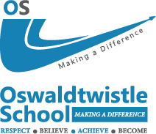 | 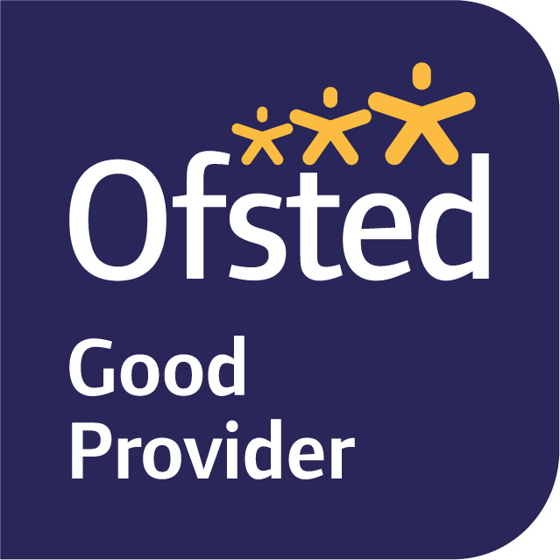

Welcome to Oswaldtwistle School,
Oswaldtwistle School is a 95-place secondary alternative provision school for young people who require something additional or alternative to the core that is offered by the mainstream sector.
The majority of our students come to us via one of 3 main pathways, as a permanently excluded student from a mainstream school in the district of Hyndburn, the Ribble Valley or Rossendale, via a referral from one of these schools when it is felt that a young person may benefit from one of our bespoke intervention packages, or by a consultant’s referral via a panel of professionals who decide that a young person may benefit from a short-term medical placement with us.
Regardless of route of entry we fully appreciate that many of the young people we work with may not have experienced a very positive time at their mainstream school and as such we work hard to reinstate their self-confidence and self-belief as we strive to re-engage them with their learning.
We aim to provide each student with a highly personalised learning experience, that will help remove any existing ‘barriers’ to learning whilst encouraging participation and achievement. We pride ourselves on the inclusive nature of our provision, the breadth of our curriculum and all that we do to help students to develop the skills, competencies and confidence they need to achieve their full potential, enjoy life and become the best they can.
Our ultimate aim is to ensure that all the young people we work with secure an appropriate destination, be it a return to a mainstream setting, a move to a special school setting, or a successful transition to the world of college, apprenticeships or work.

We would like to thank you for showing an interest in working at Oswaldtwistle School and look forward to receiving your application.

Regards
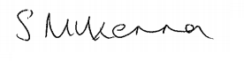
Sandra McKenna
Headteacher

