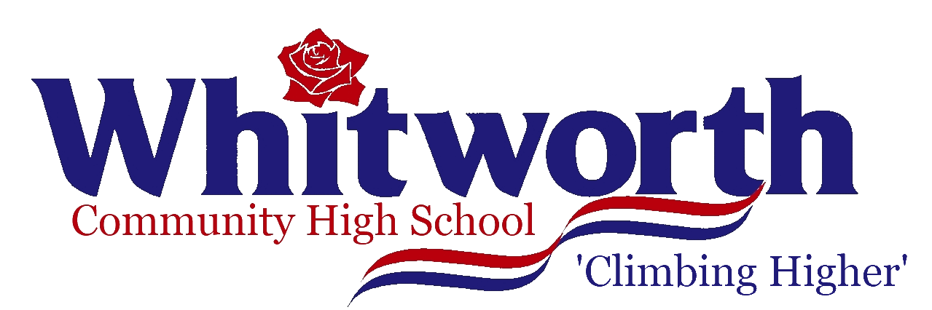

Hallfold, Whitworth, Rochdale, Lancashire OL12 8TS
Telephone: (01706) 343218, Email: recruitment@whitworth.lancs.sch.uk, Website: www.wchs.co

May 2022

Dear applicant

At Whitworth Community High School our students benefit from being part of a small school community where they feel secure and cared for, and are supported and challenged to achieve their potential. Staff benefit from being part of a fantastic team of teaching and associate staff, who work together towards our common goal: ensuring our school and our students are ‘Climbing Higher.’

Our reputation in the local and wider community is strong: families are very keen for their children to join us, all year groups are oversubscribed.

Respect is at the heart of everything we do and our 7 Expectations underpin the work of the school. We are committed to ensuring that all our young people are successful lifelong learners; confident, resilient individuals; positive contributors; and responsible citizens with clear moral values. Above all, we want them to have the highest aspirations for themselves and the self-belief needed to succeed.

We offer our students a wide and varied curriculum, to prepare them well for the demands of GCSE, alongside a great programme of extra-curricular activities: music technology, Debate Society, Science Club, choirs and bands, theatre trips, charity work, School Council, Duke of Edinburgh Bronze and Silver, and a broad range of sporting opportunities including trampolining, table tennis, football, netball and fitness. Our annual school productions involve a cast and production team from all year groups, supported by staff from all faculties. Our Ski Trip to Randstat in Austria and football/netball tours travel abroad biannually. We ensure students have many opportunities for leadership in school: as prefects, student ambassadors, council members, literacy/numeracy, environmental and charity representatives and reading buddies.

Wherever they go, our students are praised for their respectful and positive attitude and their confident and engaging manner.

Our Prospectus, on our website, is designed to give you a flavour of what Whitworth Community High School stands for. Our values and vision, and our curriculum intent are available on-line via our website. I would love you to see our school in action – to be part of the teaching and learning experience; to observe the excellent relationships between staff and students which characterise the atmosphere in school; to see the impact of our respect agenda; and to see how we are ‘Climbing Higher.’ Everyone who visits Whitworth Community High School is impressed by the warmth of the welcome, the engagement of students and the clarity of our aspirations for the future.

Best wishes

Mrs G Middlemas
Headteacher

