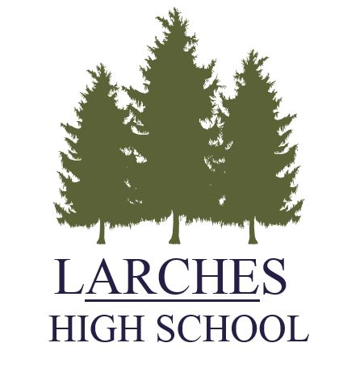
Person Specification: Teacher of Science

FACTOR | ESSENTIAL | DESIRABLE | MEANS OF ASSESSMENT
1 SKILLS, KNOWLEDGE  AND APTITUDES | - Excellent classroom practitioner.  - Clear understanding and knowledge of KS3 and KS4 Science curriculum.  - Good knowledge of assessment requirements at KS3 and KS4.  - Ability to engage children’s interest.  - Knowledge and understanding of intervention strategies and raising standards.  - Ability to communicate well with children. | - Ability to use ICT effectively in teaching and learning, | Interview  Task  Application form  References
2 QUALIFICATIONS AND  TRAINING | - Relevant degree  - Qualified Teacher Status | - Evidence of working as a reflective practitioner, using a variety of approaches to secure ongoing professional development.  - Science curriculum leadership. | Application form
3 EXPERIENCE | - Good track record of teaching KS3 and KS4 Science | .  - Experience of working with challenging pupils. | Application form  Interview  References
4 PERSONAL QUALITIES | - Well motivated and enthusiastic  - Commitment to success in education  - Willingness to accept responsibility and take initiative  - Good organisational skills  - Ability to motivate pupils  - Good teamwork and interpersonal skills  - Willingness to be innovative and ability to be creative  - Ability to form and maintain appropriate relationships and personal boundaries with pupils | - Interest in, and commitment to, the whole school as a community | Application form  Interview  References  Tasks
5. SPECIAL REQUIREMENTS | - Enhanced clearance with Disclosure and Barring Service

