
St Mary’s & St Benedict’s Catholic Primary School
Brownedge Lane, Bamber Bridge, Preston PR5 6TA
Phone: 01772 336650
email office@smsb.lancs.sch.uk
www.smsb.lancs.sch.uk
Headteacher: Mr Daniel Ballard
Wednesday, 11th May 2022
Dear candidate,
Many thanks for expressing an interest in applying for joining the Senior Leadership Team at St Mary’s & St Benedict’s. Our school is an extensive, one and a half form entry Catholic Primary School with Governor led Pre-School Provision. We operate as one school and plan our curriculum from 3 through to 11.
The successful candidate will be provided with an opportunity to shape the learning environment within the EYFS and Key Stage One phase. The successful candidate will work closely with the existing School Leadership Team to ensure all statutory requirements are met and to promote harmonious and effective learning.
St Mary’s & St Benedict’s is a thriving school with children and teachers who are totally committed to ensuring every child receives the best possible education. Moving on from the pandemic, we are working hard to give pupils the opportunities they deserve and that they have missed because of COVID.
Our school can offer any potential candidate a rich and stimulating environment to develop their teaching and leadership skills. We serve a wonderful parish and are blessed to have children whose families are extremely supportive of our school. We have a wide range of pupils from a variety of backgrounds but we are all God’s children and look to Jesus for our moral and ethical guidance.
There will be challenges for whoever is successfully appointed. Teachers, teaching assistants and support staff are all challenged to share in our determination to provide the best possible education for our children. As school leaders, we place great importance in developing a school environment where opportunities for personal and professional growth are provided.
Visits to the school are highly recommended. Please contact the school office to arrange a visit. Either myself or my Deputy Headteacher, Miss J. Mercer, will meet you and provide you with a tour of our school.
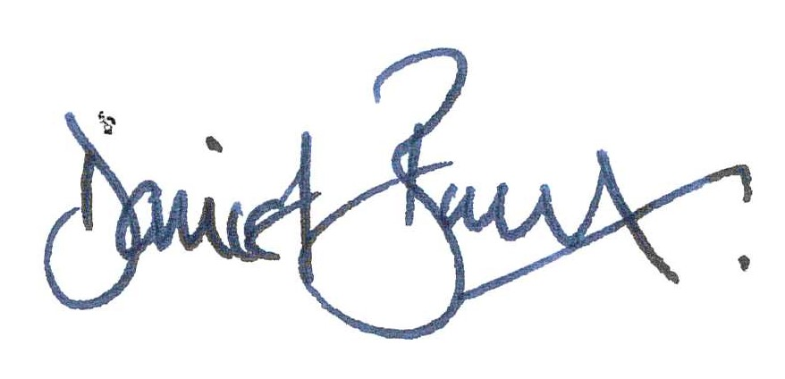
Many thanks,

Mr Daniel Ballard (Headteacher)

