
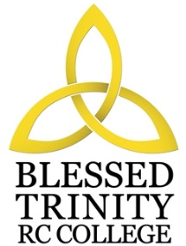

BLESSED TRINITY RC COLLEGE

PERSON SPECIFICATION

TEACHER OF MUSIC

Attributes | Essential | Desirable
Experience | Experience of teaching across the whole ability range. | Experience of Music Technology at KS4.  Some experience and knowledge of Citizenship/PHSE.
Qualification | Teaching qualification.  Degree in the relevant subject. | Recent CPD in Curriculum, willingness to take part in CPD  delivery and learning.
Special  Knowledge | Knowledge and understanding of current developments and initiatives in the delivery of the subject across the Key Stages. | Conversant with the planning and delivery of courses.
Practical and  Intellectual Skills | Commitment to the development of the extra-curricular programme.  High standard of musicianship; good keyboard skills.  Effective organisational skills.  Good communication skills, both oral and written.  Good classroom management skills. | Commitment to the development and use of ICT.
Physical | Good Health.  Excellent record of attendance and punctuality.

