
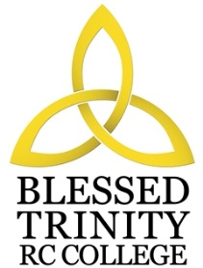

BLESSED TRINITY RC COLLEGE
JOB DESCRIPTION

Job Title Teacher of Music
Grade MPS-UPS
Responsible To Curriculum Leader – Performing Arts
Scope You will be required to teach pupils aged between 11 and 16 in Music. You will be expected to work as part of a team assisting the Curriculum Leader of the department in organisation and administration and the extra curricular life

Job Purpose The main objectives to be achieved by the post holder:

- To maintain and build upon the standards and professional duties as outlined in Teachers’ Pay and Conditions.
- To manage pupil learning through effective teaching in accordance with subject schemes of work and policies, ensuring continuity and progression.
- To deliver an appropriately broad, balanced, relevant and differentiated curriculum for pupils and to support a designated curriculum area as appropriate.
- To monitor and support the overall progress and development of pupils as a class teacher/form tutor.
- To facilitate and encourage a learning experience which provides pupils with the opportunity to achieve their individual potential.
- To contribute to raising standards of pupil attainment throughout the school.
- To contribute to the extra-curricular life both within the Music Department and as an active participant in the liturgical life of the school.
- To share and support the school’s responsibility to provide and monitor opportunities for personal and academic growth.
- To work as a member of a designated team and to contribute positively to form effective working relations within the school.

Since this is a Roman Catholic College you are expected to support and promote the Catholic ideals of the school as stated in the Vision Statement.
Note : In addition other duties at no higher level of responsibility may be interchanged with/added to this list as required.

