
St Mary’s & St Benedict’s Catholic Primary School
Brownedge Lane, Bamber Bridge, Preston PR5 6TA
Phone: 01772 336650; Fax 01772 629482
email office@smsb.lancs.sch.uk
www.smsb.lancs.sch.uk
Headteacher Mr D Ballard

Thursday 5th May 2022
Dear Candidate
The Governors are delighted that you are interested in working as a Class Teacher at St Mary’s and St Benedict’s Catholic Primary School.
St Mary’s and St Benedict’s is a popular school in Bamber Bridge, near Preston. Our school has a strong Catholic ethos that underpins all we do. The staff at St Mary’s and St Benedict’s are hardworking and friendly and a great team to belong to.
We are a well-resourced school with a supportive and dedicated Governing Body that are committed to the pupils and families of our school and also to the continuous professional development of our staff.
The children at St Mary’s and St Benedict’s are amazing and have so much potential. They are friendly, enthusiastic, keen to learn and very well behaved.
As a Headteacher, I am driven by my passion to ensure that our pupils get the very best that they deserve. Any new member of staff to our school must also share this passion and ensure that they are determined to get things right for our children.
Before submitting your application for the post, you are warmly welcomed to come and see our school in action. It is hard to put into words how special our school is so please do come and see it for yourself.
I hope to meet you soon.

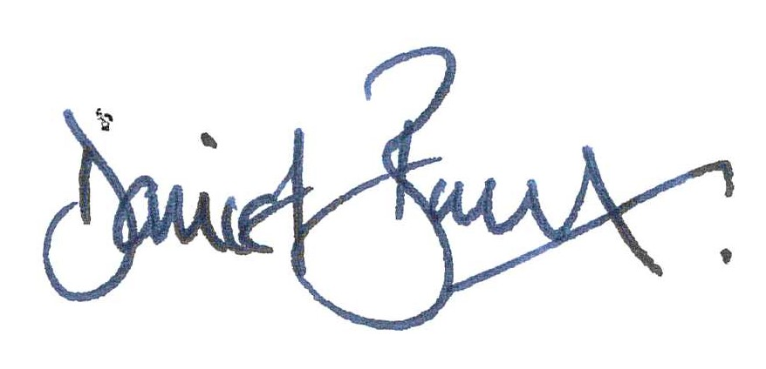

Mr Daniel Ballard
Headteacher

