
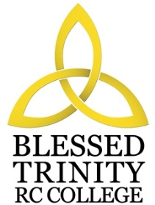

BLESSED TRINITY RC COLLEGE

PERSON SPECIFICATION

TEACHER OF RE

Attributes | Essential | Desirable
Experience | Experience of teaching across the whole ability range.
Qualification | Teaching qualification.  Degree in Theology, Religious Studies or other relevant subject. | Recent CPD in Curriculum, willingness to take part in CPD  delivery and learning.
Special  Knowledge | Knowledge and understanding of current developments and initiatives in the delivery of the subject across the Key Stages. | Conversant with the planning and delivery of courses.
Practical and  Intellectual Skills | Effective organisational skills.  Good communication skills, both oral and written.  Good classroom management skills.  Committed and practising Roman Catholic. | Commitment to the development of the extra-curricular programme.  Commitment to the development and use of ICT.
Religion |  | Practising Catholic.

