Would you like to be our new Deputy Headteacher?

We are Ellel St. John’s Church of England Primary School Council and we are very proud of our school. We are looking for a very special person to be our Deputy Headteacher – could it be you?

We want our Deputy Headteacher to:
Be kind but also firm
Be fun and have a sense of humour
Believe in God

Be organised and hard working
Be a forgiving person who respects others

Give lots of praise and see the best in everyone

Be nice and friendly
Be a good listener
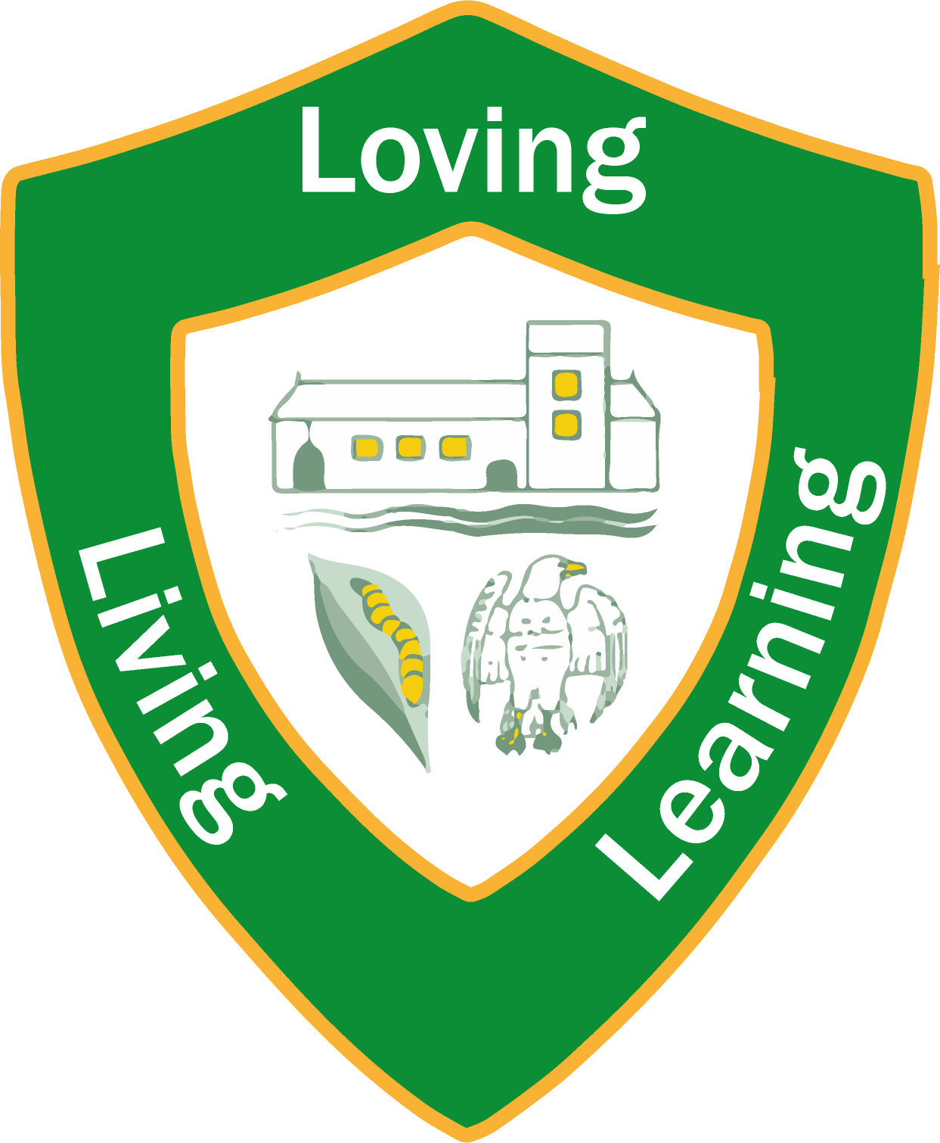
Be helpful and able to work well with others
Care about our school and everyone in it

Enjoy leading Worship

Respect the school

Be someone who is good to nature

Be someone who is approachable and interactive
Be enthusiastic and makes learning fun
Be someone who is inclusive of all pupils

Be someone who is nice to the teachers
Be confident in Worship
Have good energy
Be trustworthy

If you want to be part of our school community, we hope this will help you decide if you are the person we are looking for.

Yours sincerely,

The School Council at Ellel St. John’s Church of England Primary School

