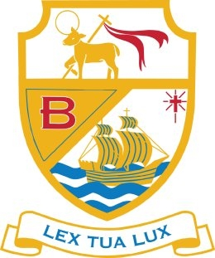

Vacancy for Curriculum Leader of Religious Education

Permanent full time appointment to commence 1st September 2022.
Salary: MPR/UPR plus TLR 1.1 (£25,714 - £41,604 plus £8,291)

The Governors wish to appoint a committed, enthusiastic and innovative Religious Studies teacher to lead the ‘Outstanding’ RE Department at St Bede’s Catholic High School. The post holder will play an important role within the school, leading the curriculum within the department.

Applications on a CES application form should be marked for the attention of Mr Denton, and received by 9.00am on Monday 17th January, 2022. Interviews will be held on Wednesday 26th January, 2022.

Supporting statements, which should be no more than two sides of A4, should address your suitability for the role and detail the ways in which you would lead the future development of Religious Education at St Bede’s Catholic High School.

Job description and person specification is available to download from the school website www.sbchs.co.uk Please return completed applications to Julie Taylor j.taylor@sbchs.co.uk

