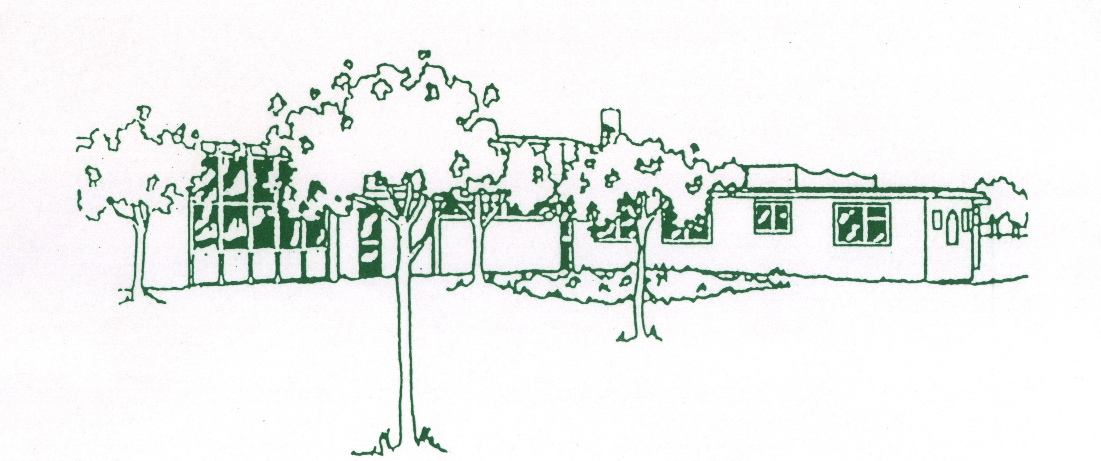
Bispham Road
Carleton
Poulton-le-Fylde
Blackpool FY6 7PE

Tel: 01253 882225
Fax: 01253 895920
E-mail: head@sthildas-carleton.lancs.sch.uk

Carleton St. Hilda’s C.E. Primary School


Headteacher: Mrs. H. Wareing

Dear future Headteacher

Thank you for being interested in joining our school family here at Carleton St Hilda’s Church of England School.

We are a happy and welcoming school where we understand and respect each other. The adults in school are fun and fair, they think of lots of different exciting ways to learn. We have a bright and beautiful outdoor space, including a conservation area which we enjoy using. We even have an extraordinary orienteering course.

We are proud of everything we achieve and how far we have come over the years. There are many things that we are proud of, such as:
- Our school environment (including our grounds and classrooms)
- Our school family (teachers, friends, Canon Martin, Reverend Lois and the people around us)
- Our sports teams (we are enthusiastic about football and netball)
- The learning opportunities provided to us
- Our outstanding behaviour (when we are out of school, people tell the staff how well behaved we are!)
- Our Christian values that we show and follow
- Responsibilities within school (year 5 buddies with reception, school council, worship leaders, sports crew)
- Our link with St Hilda’s church (we enjoy worship and the opportunities to share in worship at church)

We would like a happy and smiley headteacher who takes care and supports everybody in our family, no matter their race or religion. We would like someone who is thoughtful, confident and determined to lead our school; someone who connects us together with God and Jesus, and involves us in worship by asking us questions and inviting us to the front (we love acting out stories from the Bible).

We would like the opportunity to be able to: share good news and work that we are proud of, and talk to you if we are upset or worried. We love sharing in and celebrating school events including: sports week, spirituality day, and the exciting and important times of the Church calendar. Our school teams are very important to us (Air, Earth, Fire or Water) and we cannot wait to see which team you decide to join.

We hope that you enjoyed reading our letter and that you will apply to join our school family.

Yours sincerely

Year 5

