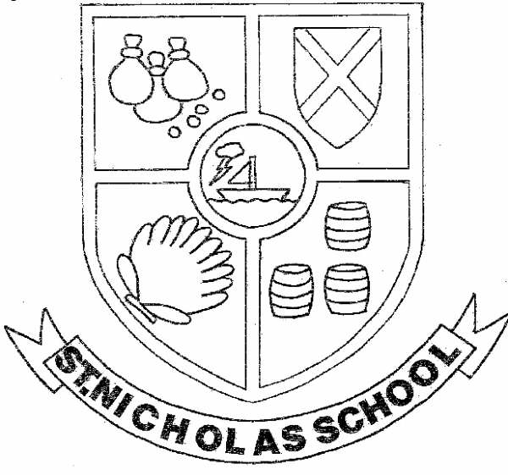 | CHURCH ST NICHOLAS CE PRIMARY SCHOOL  ‘Growing together in our Love for God, Learning and Life’  St Nicholas Road  Dill Hall Lane  Church  Accrington  BB5 4DN
Headteacher  Mrs V Axon BA Hons (QTS) NPQH  Telephone Fax  01254 381875 01254 350084 |  | Email  head@st-nicholas.lancs.sch.uk

July 2021.
Dear Applicant
On behalf of the Governing Body of Church St Nicholas Church of England Primary School I would like to thank you for your interest in the post of Headteacher.
We are looking for the right person to lead our school on the next stage of the journey. It is very important that we employ someone with a strong faith and clear understanding of what it means to lead a Church of England primary school. In return, we offer you a warm and caring environment where all are encouraged to thrive and have a love of God, Learning and Life.
At Church St Nicholas Church of England Primary School we have a strong Christian ethos routed in Gospel values. Our strong links with the local church of St Andrew’s is very important to us as is our commitment to providing regular community services at school.
St Nicholas is a happy school where the children are friendly, polite and keen to learn. The expectations for learning and behaviour are very high as we want all children to achieve their full potential, develop skills across all areas of the curriculum and have a Growth Mindset. We have a successful approach to nurture and support to help our most vulnerable pupils .We also use Trauma Informed practise.
As a school we simply want the best outcomes for all our children. To achieve this we are looking for a skilled professional with excellent management and interpersonal skills who can lead and inspire all the members of our school family.
You are warmly invited to arrange an informal visit to school. Please contact the school office on 01254 381875 to arrange a visit.
We look forward to receiving your applications.
Yours sincerely

Peter Blackburn.
Chair of Governors.

