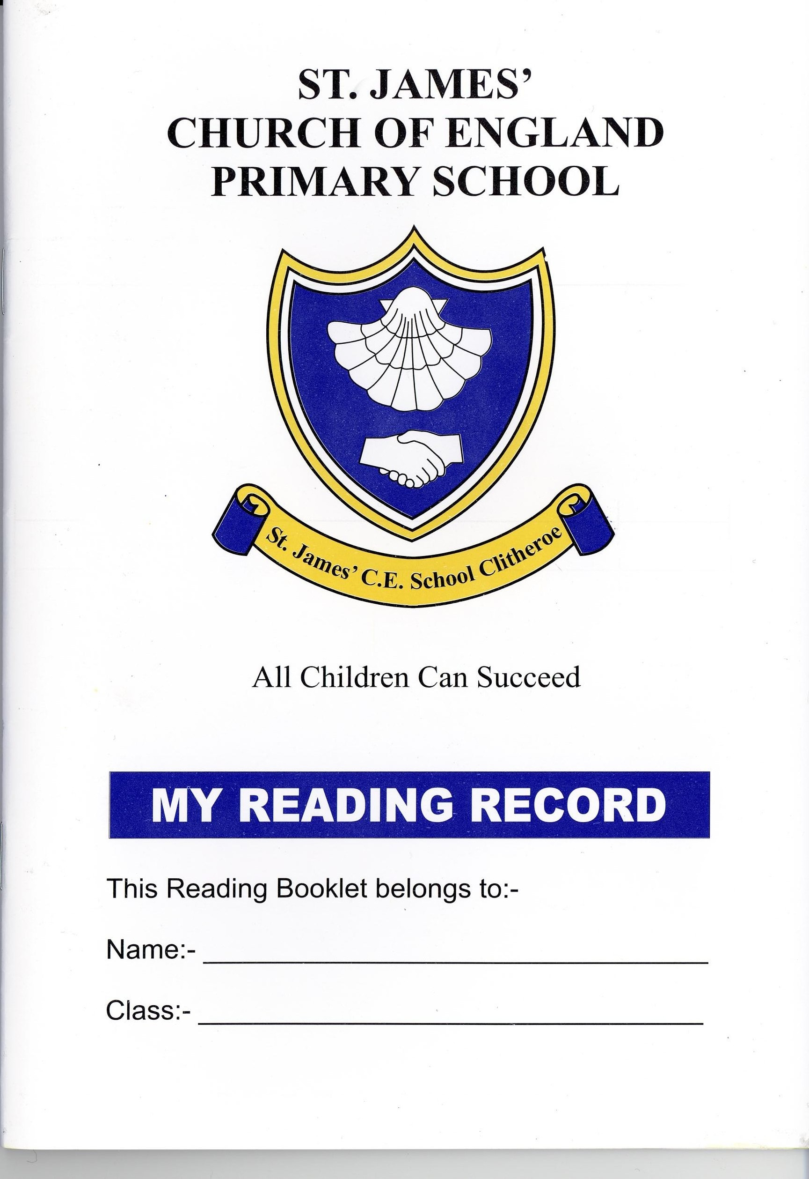
CLITHEROE ST JAMES’ C.E. PRIMARY SCHOOL

Headteacher: Mrs F.M. Pattison BEd(Hons) NPQH

Tel: 01200 423599 Email: head@st-james.lancs.sch.uk

School website: www.stjames-clitheroe.co.uk

Greenacre Street, Clitheroe, Lancashire, BB7 1ED

July 2021

Dear Candidate,

Thank you for your interest in becoming our new headteacher. Mrs Pattison has led us brilliantly so far on our St. James’ Journey and we now need another special person to carry this on.

We really would like our new headteacher to be kind, caring and treat us all equally but also to see us as individuals. We would like our headteacher to be fun, to listen to us all but also to guide us and be firm when necessary. We always need to feel safe and secure, to respect each other and our school.

To carry on our St. James Journey, we would like a headteacher that can motivate, inspire, and help us all to work together to be the best that we can be.

It would be wonderful for you to bring some of your ideas on board and to join our amazing school family. In school we always try to be strong and courageous as God is with us on our journey. We hope that you can be to.

Thank you for reading our letter,

Hawthorn Class Children (Year 3 and 4)

