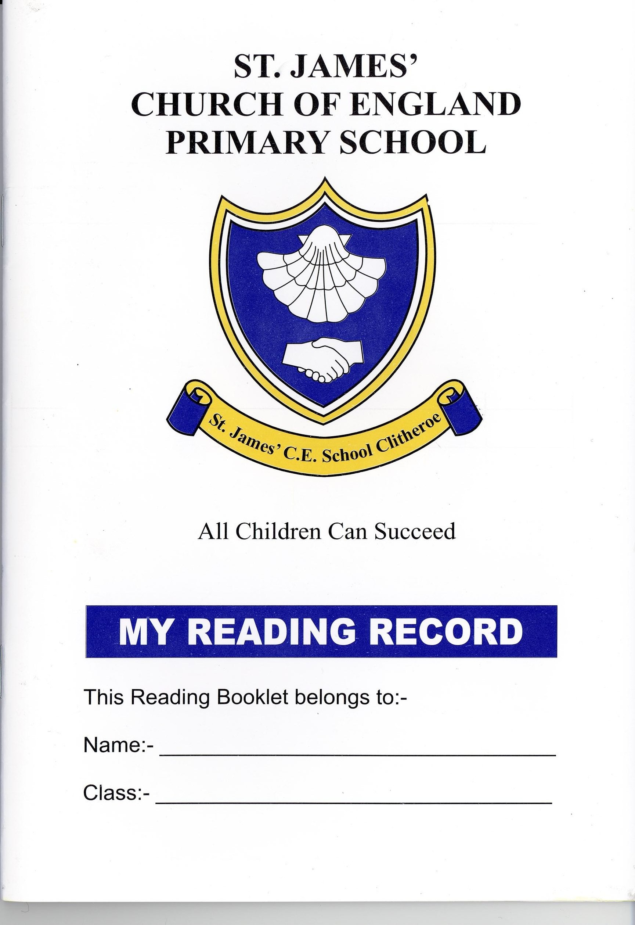
CLITHEROE ST JAMES’ C.E. PRIMARY SCHOOL

Headteacher: Mrs F.M. Pattison BEd(Hons) NPQH

Tel: 01200 423599 Fax: 01200 443249 Email: head@st-james.lancs.sch.uk

School website: www.st-james78.langsngfl.ac.uk Online Learning: http://vle.st-james.lancs.sch.uk

Greenacre Street, Clitheroe, Lancashire, BB7 1ED

12th July 2021

Dear Candidate,

Thank you for your interest in the post of headteacher at Clitheroe St. James’ CE Primary School. The vacancy has arisen due to the planned retirement of the current headteacher.

Situated in a thriving market town in the scenic Ribble Valley, Clitheroe is within easy reach of the motorway network and has rail and easy road access to Manchester and the North West. Our annual admission number is 45 accommodated in 11 classes. Bowland Pre-School, which is accommodated within our school site, offers places to children aged 2-4 who frequently proceed onto our EYFS group.

Governors are passionate about the holistic development and well-being of every child who attends our school. We are proud of the ethos at Clitheroe St. James’ where every child feels happy and valued as part of our ‘school family’. The successful candidate will be an inspirational leader who will maintain and develop this and continue with the St. James’ Journey.

From January 2022, the classes will be housed in 2 adjacent buildings following the completion of our new EYFS/KS1 department. We also have exciting plans for the refurbishment of our KS2 facilities which a successful candidate would be an integral part of.

We are blessed with extensive and engaging school grounds, including an Eco Zone and outdoor classroom, which are at the forefront of our move to achieve Forest School status. The large grounds lead onto a recently developed community nature reserve; this offers a pleasant route to school for our families, as well as opportunities for the children to explore the environment during school hours.

We are very supportive Governing Body who are excited by the prospect of working alongside our new headteacher to take our school onto the next stage of its journey.

The closing date for applications is Friday 17th September at 12 noon with shortlisting taking place on Monday 27th September. Interviews will take place on Friday 15th October with pre-interview sessions the day before. If you would like to visit the school prior to making an application, please contact the school office (01200 423599) and the headteacher, Fiona Pattison, would be pleased to welcome you:

When completing your application form please follow these guidelines:
- Complete your application online, submitting the Blackburn Diocese Application Form.
- Ensure that your supporting letter does not exceed three sides of A4, minimum size 11 font. Please do not submit a CV instead of an application form.
- Refer to the diocesan guidance on faith references included in the application pack.

Many thanks for showing an interest in our amazing school and we look forward to receiving your application.

Yours sincerely

Mark Clayton

Chair of Governors

