Rev’d Mark Pickett
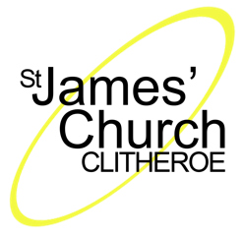
The Rectory, Woone Lane, Clitheroe, Lancashire, BB7 1BJ
Telephone: 01200 429327 Email: markwlpickett@googlemail.com
Registered Charity number: 1131419

12th July 2021

Dear Candidate

We are pleased that you are interested in the Headteacher position at Clitheroe St James’ CE Primary School. As Rector of St James’ Church for the last 18 years, I want to tell you that we are so much more than just an ordinary church school.

For the last 5 years, the church has employed a Children’s and Families’ Minister with a specific mandate to make connections with school and school families. We specifically set aside 10 hours of her working week to be dedicated to ministry in the school in consultation with the Headteacher. This has resulted in a very special relationship with children, staff and families and there is a real synergy between church and school. We don’t focus on getting people to come to church, but we are intentional about taking church to school. The ministry with Transforming Lives for Good (TLG) and the partnership with Kings Highway school in Kenya have, if you like, been concrete examples of church instigating specific projects. Being a church school, though, is more about how we work together to bring transformation to the lives of folk in our community. St. James’ Church is a welcoming environment that children enjoy visiting with the school for special occasions as well as attending exciting children’s activities during the week. Many of our school families choose to engage regularly with a range of activities hosted by our church.

We would be delighted if you wanted to join us on this journey and our Children’s and Families’ Minister and I look forward to meeting you to share more of our vision for church and school working together.

Blessings

Revd Mark Pickett: Rector of St. James’ Church Clitheroe
Mark Pickett

Helen Potts: Children and Families Minister (01200 423608)
Helen Potts

