Poulton-le-Sands C.E. Primary School

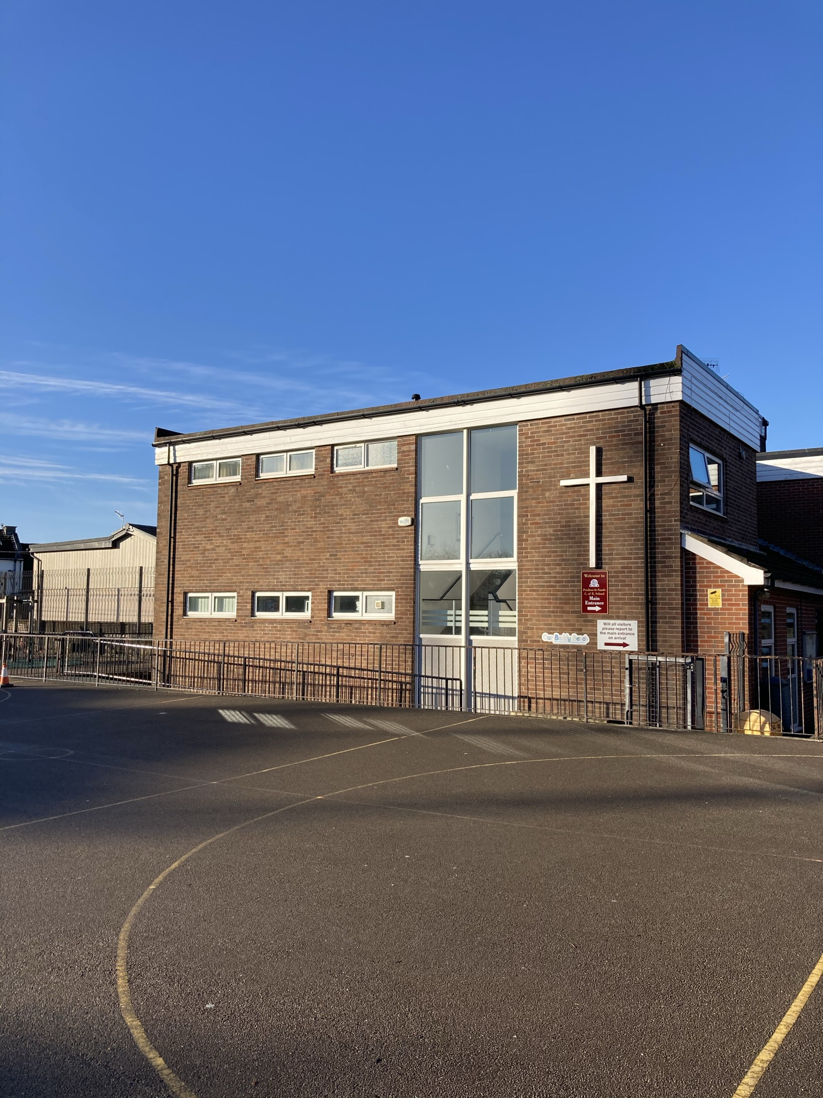

The school is an aided Church of England Primary School within the Parish of Holy Trinity with St. Laurence (Morecambe Parish Church), standing adjacent to the church in the east end of Morecambe. The school derives its name from the ancient village of Poulton-le-Sands, one of the villages around which Morecambe developed in the 19th century after it was linked to the main London-Carlisle railway line at Lancaster.

The present building was opened in 1967 and is the third on the site. It replaced a mid-19th century building, which in turn had replaced the original school, founded by the Will of Francis Bowes in 1745, said to have been the village blacksmith. The well-maintained building has been added to and improved on several occasions.

There are seven classes, a multi--purpose hall, a library, Computing Suite, 2 small group rooms, kitchen, staff room, PPA room and an entrance hall with school office.

The staff comprises of the Head teacher, Deputy Head teacher, Assistant Headteacher and eight teachers, some part time. The Senior Leadership Team consists of the head teacher, deputy head teacher and assistant head teacher.

We have a fulltime family and pupil support worker. Our school business manager works three days a week and a school administrator works in the office on Wednesdays and Fridays and deals with dinner money. There are seven teaching assistants, working across the classes, and four additional teaching assistants supporting children with special educational needs. The school has assistance from outreach teachers. A senior mid-day supervisor and nine welfare assistants are employed over the mid-day break.

At present there are 172 children on roll, organised in seven classes so that each class has a mixed ability range. Our maximum intake number is 30.

The Governors regard the maintaining of close links between the school and the Church as of great importance. Prior to Covid restrictions, on one morning each week the children attend a service in Church conducted by the Rector or member of the clergy team. We hold a harvest festival service in October, a Carol Service before Christmas, an annual Founder’s Day Service in February and a Leavers’ Service in July. Parents are welcome to attend all our church services.



