
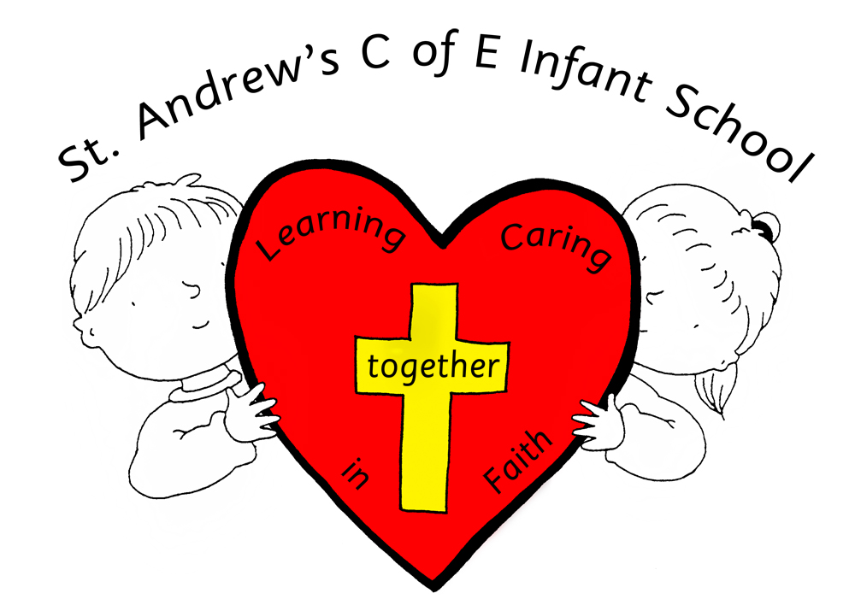
ST ANDREW’S C of E INFANT SCHOOL
WOODLEA ROAD, LEYLAND, PR25 1JL

Headteacher: Mrs P Corry E-mail: head@st-andrews-inf.lancs.sch.uk
Tel: 01772 423339 Website: www.standrewsinfants.co.uk
Fax: 01772 459096

Dear Applicant

We thank you for your interest in the post of Head Teacher at St. Andrew's Church of England Infant School. We are all enormously proud of our school and the achievements of our pupils and pleased that you are considering joining us. This is an exciting opportunity to join a friendly, welcoming school where ‘Learning and Caring Together in Faith’ forms the basis of all that we do both in school and in the local community.

St. Andrew's is a voluntary controlled Church of England Infant school in the heart of Lancashire offering primary education for children aged 4 to 7years of age.

St. Andrew’s staff make up a cohesive, committed and hardworking team where children are eager to learn and where we encourage them to develop self-resilience and positive attitudes to build their learning in a happy and lively environment. We have a good relationship with parents and families and are very supportive with an active and successful P.T.A. There are strong links with the Church, Parish and wider community. Our St. Andrew’s family is a special place to be.

The school has a developing governing board, with a number of recently recruited, highly skilled and experienced governors who all want the best for the school. Our top priority is to recruit a resilient headteacher with a proven and adept record in school improvement and change management, an ambitious leader, who places children at the heart of all they do, and someone whom we are committed to work in partnership with to ensure that our pupils and our staff are provided with all they need to “be the best we can be."

We are looking to appoint someone who is committed and confident in their Christian faith, someone who will have the vision, drive and enthusiasm to take us along the next stage of our journey and be an inspirational Head Teacher. That person will embrace our strong Christian faith ethos, values and vision and work towards continuing and increasing the success of our school.

Yours Sincerely

Andrew Bluck

Chair of Governors

