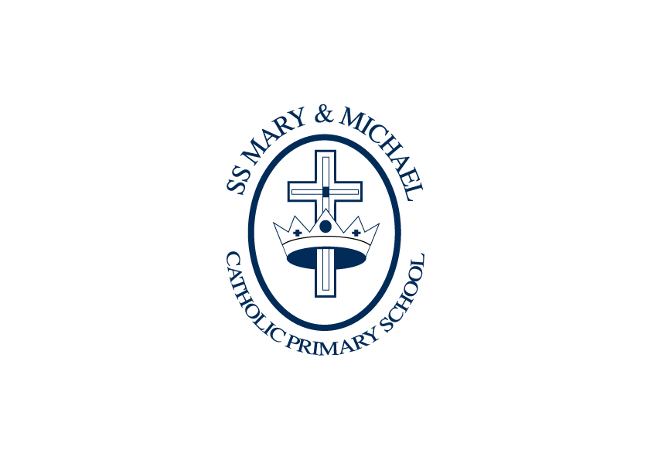
SS Mary and Michael Catholic Primary School

Classroom Teacher for EYFS/Year 1 Class
Person Specification Form

Personal attributes required  (based on the job description) |  | Essential (E)  or  Desirable (D) | To be identified by: application form (AF),  interview (I),  test (T), reference (R) or  other (give details)
Qualifications
Qualified Teacher Status |  | E | A
CCRS or commitment to obtaining the certificate. |  | E | A
Recent participation in a range of relevant in-service training |  | D | A
Church Distinctiveness
To be a practising Catholic |  | D | A
To uphold the Catholic ethos of the school |  | E | A
To participate fully in the wider life of the catholic School ie. worship/ church links |  | E | A, I
Experience
Experience of EYFS Reception |  | D  E | A, I
Recent classroom teaching experience in primary school |  | D  E | A, I
Experience of working with children with SEND |  | D  E | A, I
Experience of teaching and assessing phonics |  | D  E | A, I
Knowledge, skills and abilities |  |  | A, I, R
Have high expectations of all pupils |  | E | A, I, R
Engage and inspire the interests of learners |  | E | A, I, R
Effectively lead and manage support staff |  | E | A, I, R
Outstanding classroom management and organisation |  | E | A, I, R
Outstanding behaviour management |  | E | A, I, R
Plan sequences of lessons with clearly differentiated learning objectives, linked to prior attainment which meets the needs of individual learners |  | E | A, I, R
A Clear understanding of how assessment for learning practices support teaching and learning |  | E | A, I, R
Use a range of strategies to provide feedback to pupils |  | E | A, I, R
Closely assess, track, record and report pupils’ progress |  | E | A, I, R
Ability to manage a remote learning offer if necessary |  | E | A, I, R
Professional knowledge and understanding |  | E | A, I, R
National policies, priorities and statutory frameworks |  | E | A, I, R
Assessment and tracking of pupil progress (especially Development Matters and early Learning Goals) |  | E | A, I, R
Application of ICT to teaching and learning |  | E | A, I, R
Ability to create and promote a stimulating learning environment for all learners |  | E | A, I, R
Good understanding of and commitment to inclusion, Child Protection and Safeguarding |  | E | A, I, R
Understanding of mastery/metacognition and growth mindset strategies |  | D | A, I, R
Personal Skills and attributes
Supportive of the Catholic ethos of the school |  | E  E | I, R  I, R
Excellent communication and interpersonal skills |  | E  E | I, R  I, R
Ability to prioritise time effectively |  | E  E | I, R  I, R
Flexibility |  | E  E | I, R  I, R
Personal impact and enthusiasm |  | E  E | I, R  I, R
Self-confidence and presence |  | E  E | I, R  I, R
Commitment and integrity |  | E  E | I, R  I, R
Ability to work as a team |  | E  E | I, R  I, R
A willingness to further professional development |  | E  E | I, R  I, R
A willingness to participate in the wider life of the school, including extra-curricular activities |  | E  E | I, R  I, R
Other (including special requirements)  - Commitment to safeguarding and protecting the welfare of children and young people  - Commitment to equality and diversity  - Commitment to health and safety  - Commitment to sustaining regular attendance at work |  | E  E  E  E | I, R  I, R
Prepared by: | A J Parry | Date: | March 2021
Note: We will always consider your references before confirming a job offer in writing.

